

**Information Technology Institute**

**Power BI Development Track**

**Aura Hospital Management System**

Supervisor:

Eng. **Omnia El_Sheikh**

**Presented by:**

Alaa Ahmed Abdullah

Aya Nabil Sakr

Mostafa Mohamed Mahmoud

Yasmen Shafik Elnaggar

Youssef Muhammad Mahmoud Ahmed

Introduction

**Purpose:**  
This document provides a complete overview of the Hospital Management System. It explains the project’s objectives, structure, database design, and core functionalities to ensure clear understanding for developers, stakeholders, and end users.

**Scope:**  
The system manages hospital operations such as patient registration, lab test and radiology reservations, expense tracking, and report generation. It aims to automate manual workflows, reduce human error, and improve patient service efficiency.

**Technologies Used:**

* Drawio (ER Diagram & Mapping)
* SQL Server (Database + Stored Procedures + Views)
* SQL Data Generator
* SSRS (Reports)
* Power BI (Datawarehouse & Dashboards)

Objectives

The main objectives of the system are:

1. **Patient Data Management**
   * Maintain complete patient profiles, including personal data, contact information, and medical history.
   * Track appointments, surgeries, tests, radiology, prescriptions, and diagnoses to support accurate and safe clinical decision-making.
2. **Scheduling and Reservation Management**
   * Organize doctor appointments, surgeries, room reservations, laboratory tests, and radiology bookings.
   * Manage room availability and staff assignment efficiently.
3. **Financial and Billing Management**
   * Track revenues generated from different services (surgeries, tests, radiology, consultations, room stays, pharmacy sales).
   * Generate and store invoices for all types of reservations and purchases.
4. **Operational and Performance Analysis**
   * Monitor performance for departments, doctors, rooms, and services.
   * Provide dashboards and KPIs to support data-driven decisions and service improvement.
5. **Pharmacy and Inventory Management**
   * Manage drugs and pharmacy stock, including quantities, expiry dates, prices, and sales.
   * Alert management to low stock and near-expiry items.
6. **Attendance and HR Monitoring**
   * Track employee attendance, shifts, delays, and absences.
   * Support HR and management in evaluating staff commitment and workload.

Database Design

**1. Patient Management**

* Patients
* Room_Reservation
* Appointment_Reservation

**2. Laboratory Module**

* Lab_Tests
* Lab_Reservation

**3. Radiology Module**

* Radiology
* Radio_Reservation

**4. Finance & Billing**

* Invoice
* InvoiceDetails
* Expenses
* Expenses_Type

**5. Scheduling & Appointments**

* Doctor_Appointments
* Appointment_Reservation
* Shift
* Shift_Appointment

**6. Pharmacy & Prescriptions**

* Prescription
* Pharmacy_Drugs

**7. Medical Records**

* Diagnose_History

**8. HR & Payroll**

* Employee
* Attendance
* Salary
* Deduction
* Reward

**9. Core System Setup**

* Department
* Room

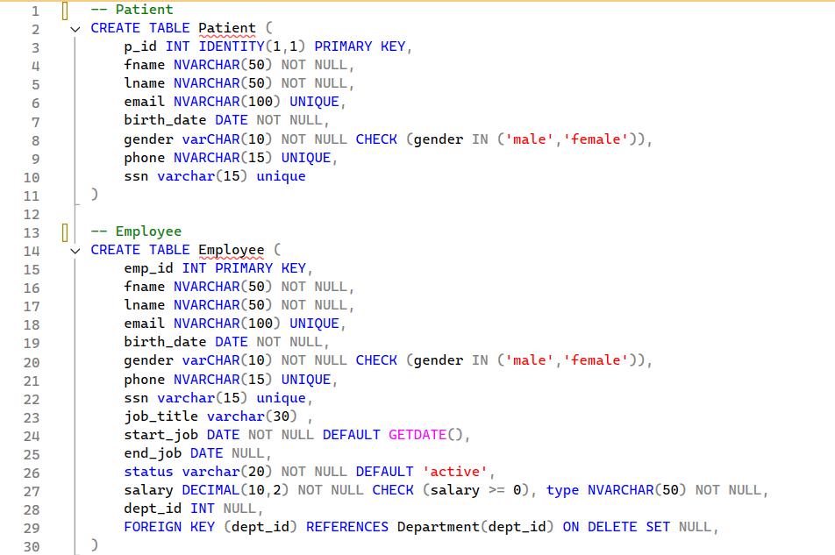

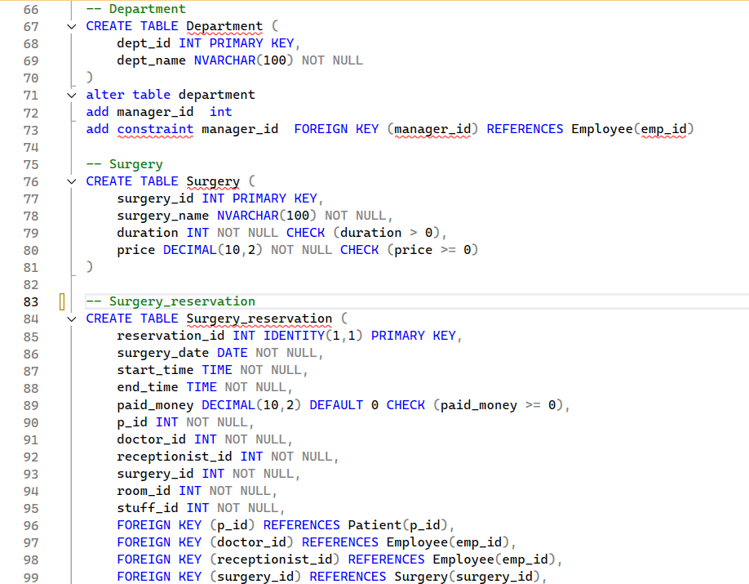

Stored Procedures

**SP_CheckInEmployee**

This stored procedure manages the daily check-in process for employees.  
It validates the employee’s existence and status, ensures there is no check-in already recorded for the same day, and then inserts a new attendance record if all checks pass.  
A descriptive status message is returned to indicate the outcome of the operation.

**Execution flow:**

* Receives the employee ID @emp_id and an optional check-in datetime @checkin.
* If @checkin is NULL, it sets @checkin to the current server datetime using GETDATE().
* Checks the Employee table to verify that a record exists for the given @emp_id:
  + If no employee is found, it sets @Message to *"Employee not found in the system"* and exits.
* Checks if the employee is marked as Inactive in the Employee table:
  + If the employee is inactive, it sets @Message to *"Employee is inactive and cannot check in"* and exits.
* Checks the Attendance table for an existing record for the same emp_id and the same attend_date (derived from CAST(@checkin AS DATE)):
  + If a record already exists for that date, it sets @Message to *"Employee already checked in today"* and exits.
* If all validations pass, it inserts a new row into Attendance with:
  + emp_id = @emp_id
  + checkin = @checkin
  + checkout = NULL
  + attend_date = CAST(@checkin AS DATE)
* After a successful insert, it sets @Message to *"Check-in recorded successfully"*.

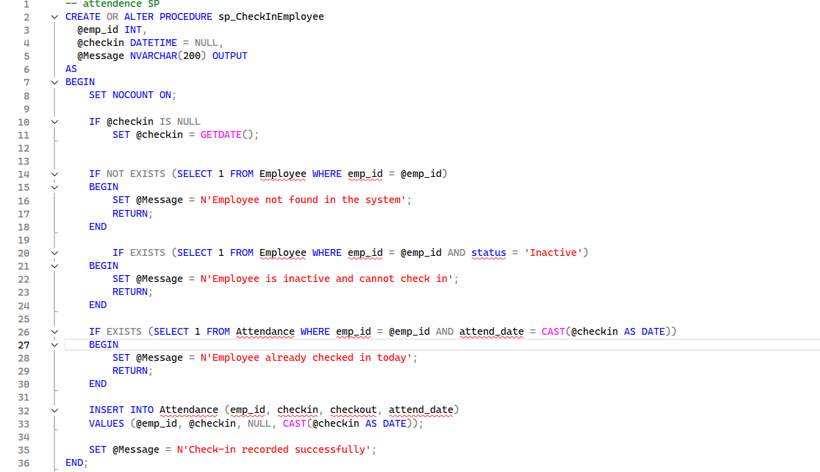

**SP_CheckOutEmployee**

This stored procedure manages the daily checkout process for employees.  
It ensures that the employee has already checked in today, prevents multiple checkouts for the same day, updates the checkout time, and then triggers the attendance deduction calculation.  
A status message is returned to indicate the outcome of the operation.

**Execution flow:**

* Receives the employee ID @emp_id and an optional checkout datetime @checkout.
* If @checkout is NULL, it sets @checkout to the current server datetime using GETDATE().
* Derives the current attendance date as @today = CAST(@checkout AS DATE).
* Checks the Attendance table for a record matching the given @emp_id and @today:
  + If no attendance record is found, it sets @Message to **"No check-in found for this employee today"** and exits.
* Checks if there is already an attendance record for the same employee and date where checkout is not NULL:
  + If a checkout already exists, it sets @Message to **"Employee already checked out today"** and exits.
* If validations pass, it updates the Attendance record for that employee and date, setting:
  + checkout = @checkout.
* Declares a local variable @deductionMsg and calls the procedure sp_CalculateAttendanceDeduction with:
  + @emp_id
  + @attend_date = @today
  + @Message = @deductionMsg OUTPUT  
    to calculate any related attendance deduction.
* After the checkout is successfully updated (and deduction calculation executed), it sets @Message to **"Checkout recorded successfully"**.

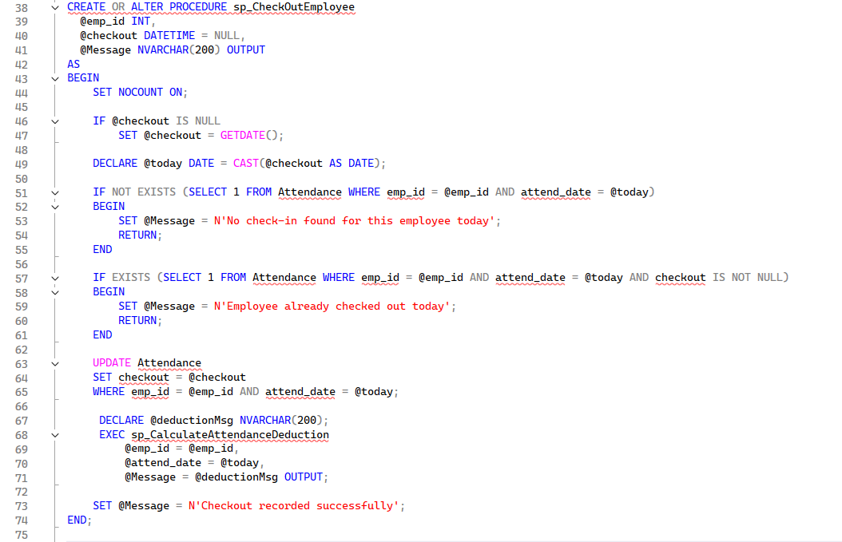

**SP_CalculateAttendanceDeduction**

This stored procedure calculates and applies attendance deductions for an employee based on their check-in and checkout times compared to their assigned shift.  
It supports both doctors and non-doctors, derives a daily salary from the monthly salary, and applies different deduction rules for lateness, early leave, or both.  
It is typically executed automatically after the employee checks out.

**Execution flow:**

* Receives @emp_id, @attend_date, and an output message parameter @Message.
* Reads the employee’s type (@emp_type) and @monthly_salary from the Employee table:
  + If no employee is found, sets @Message = 'Employee not found' and exits.
* Calculates the daily salary as:  
  @daily_salary = @monthly_salary / 30.0.
* Determines the scheduled shift for the given date:
  + If the employee is a **Doctor**:
    - Selects @shift_start and @shift_end from Doctor_appointments for that @emp_id and weekday (DATENAME(WEEKDAY, @attend_date)).
  + Otherwise (non-doctor):
    - Selects @shift_start and @shift_end from Shift_appointment for [date] = @attend_date.
  + If no shift is found (either start or end is NULL), sets @Message = 'No shift found for this date' and exits.
* Fetches @checkin and @checkout from the Attendance table for the given @emp_id and @attend_date:
  + If @checkin is NULL, sets @Message = 'No attendance record found for this date' and exits.
  + If @checkout is NULL, sets @Message = 'Employee did not check out' and exits.
* Calculates lateness and early leave:
  + @delay_minutes = minutes between @shift_start and CAST(@checkin AS TIME); if negative, it is set to 0.
  + @early_minutes = minutes between CAST(@checkout AS TIME) and @shift_end; if negative, it is set to 0.
* If both @delay_minutes and @early_minutes are 0:
  + Sets @Message = 'No deduction — employee was on time' and exits.
* Determines deduction amount and type based on rules:
  + If **both** delay and early leave > 0:
    - @deduction_amount = @daily_salary (full-day deduction).
    - @deduction_type = 'Full day deduction: Delay (X min) & Early Leave (Y min)'.
  + Else if **delay only** > 0:
    - If delay < 60 minutes:
      * @deduction_amount = @daily_salary * 0.1 (10% of the day).
      * @deduction_type = 'Delay < 1h (X min)'.
    - If delay ≥ 60 minutes:
      * @deduction_amount = @daily_salary * 0.5 (50% of the day).
      * @deduction_type = 'Delay >= 1h (X min)'.
  + Else if **early leave only** > 0:
    - @deduction_amount = @daily_salary * 0.5.
    - @deduction_type = 'Early Leave (X min)'.
* Clears any existing deduction for that employee and date by deleting from Deduction where emp_id = @emp_id and [date] = @attend_date.
* Inserts a new record into Deduction with:
  + emp_id, Ded_type, [date], and amount = @deduction_amount.
* Sets the output message @Message to:  
  'Deduction applied: ' + @deduction_type + ' - Amount: ' + @deduction_amount.

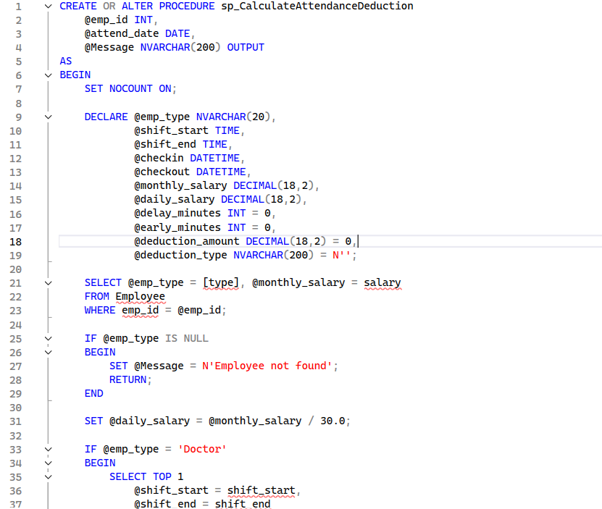

**SP_HandleMissingCheckout_SetBased**

This stored procedure automatically handles cases where employees did not perform a checkout.  
It is intended to be executed periodically (e.g. every 30 minutes) by a SQL Server Agent job to detect attendance records with missing checkout after the shift end plus a grace period, set an automatic checkout time, and apply a full-day deduction.

**Execution flow:**

* Initializes:
  + @now with the current server datetime (GETDATE()).
  + @grace_minutes with a fixed grace period (30 minutes) after shift end.
* Drops the temporary table #MissingCheckout if it already exists.
* Builds a temporary table #MissingCheckout that contains all employees who:
  + Have an Attendance record where checkout IS NULL.
  + Have a defined shift end time (for that date and employee).
  + Have passed the shift end time **plus** the grace period (@grace_minutes) compared to @now.
* For each qualifying attendance row, calculates the effective shift_end datetime:
  + If the employee is a **Doctor**, uses data from Doctor_appointments for the corresponding weekday.
  + If the employee is **not a Doctor**, uses Emp_shift and Shift_appointment for that date.
  + Handles special/edge cases:
    - If shift end time is 00:00:00, treats it as 23:59 of the next day.
    - If shift_end is earlier than shift_start (overnight shifts), it shifts the end to the next day.
    - Otherwise, combines attend_date with the configured shift_end time.
* Populates #MissingCheckout with:
  + emp_id
  + attend_date
  + monthly_salary
  + Computed shift_end datetime.
* Updates the Attendance table:
  + Sets checkout = shift_end for all rows found in #MissingCheckout (i.e. auto-checkout at shift end).
* Cleans up previous deductions:
  + Deletes from Deduction any existing records for the same emp_id and date found in #MissingCheckout to avoid duplicates.
* Inserts new deductions into Deduction:
  + For each row in #MissingCheckout, inserts:
    - emp_id
    - ded_type = 'No checkout - Full day deduction'
    - [date] = attend_date
    - amount = monthly_salary / 30.0 (one full day salary).
* Drops the temporary table #MissingCheckout at the end.

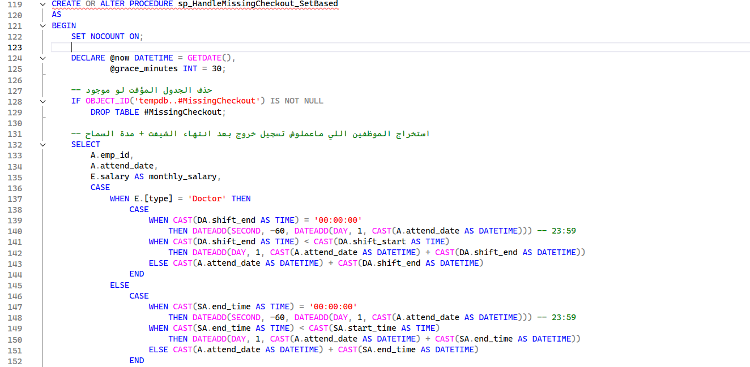

**SP_InsertManualDeduction**

This stored procedure is used to add manual deduction entries for an employee.  
It validates the employee’s existence and status, checks the deduction amount, sets a default date if needed, and then inserts a manual deduction record.  
A status message is returned to indicate whether the deduction was added successfully or why it was rejected.

**Execution flow:**

* Receives:
  + @emp_id: Employee ID.
  + @deduction_type: Description/type of the manual deduction.
  + @amount: Deduction amount.
  + @deduction_date: Optional date for the deduction (defaults to today if not provided).
  + @Message: Output parameter for the result message.
* Checks the Employee table to verify that the employee exists:
  + If no employee is found, sets @Message = 'Employee not found' and exits.
* Checks if the employee is marked as Inactive:
  + If inactive, sets @Message = 'Employee is inactive and cannot add deduction' and exits.
* Validates the deduction amount:
  + If @amount <= 0, sets @Message = 'Deduction amount must be greater than zero' and exits.
* If @deduction_date is NULL:
  + Sets it to the current date: CAST(GETDATE() AS DATE).
* Inserts a new row into the Deduction table with:
  + emp_id = @emp_id
  + Ded_type = 'Manual - ' + @deduction_type
  + [date] = @deduction_date
  + amount = @amount
* Sets the output message @Message to:  
  **'Manual deduction added successfully'**.

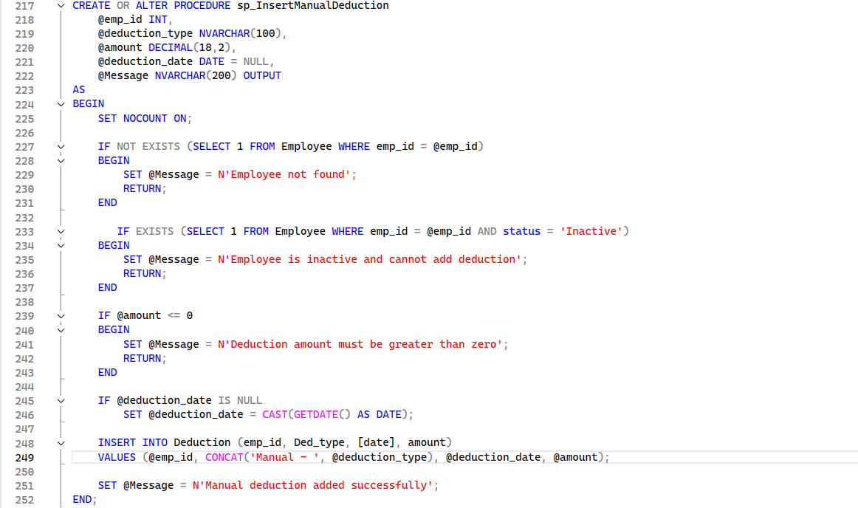

**SP_AddDepartment**

This stored procedure is responsible for creating a new department.  
It validates that the department name is unique, optionally verifies the manager, ensures the manager is active and not already assigned to another department, then inserts the new department with a generated ID.  
A status message is returned to indicate whether the department was created successfully or why the operation was rejected.

**Execution flow:**

* Receives:
  + @dept_name: The name of the new department.
  + @manager_id: Optional manager employee ID.
  + @Message: Output parameter for the result message.
* Checks if a department with the same name already exists in the Department table:
  + If found, sets @Message = 'This department name already exists' and exits.
* If @manager_id is not NULL:
  + Verifies that the manager exists in the Employee table:
    - If no employee is found with that ID, sets  
      @Message = 'Manager ID not found in Employee table' and exits.
  + Verifies that the manager is **active**:
    - If the manager is not active, sets  
      @Message = 'This manager is inactive can not be a manager' and exits.
  + Checks if the same manager is already assigned to another department:
    - If a department with that manager_id already exists, sets  
      @Message = 'This manager is already assigned to another department' and exits.
* Generates a new department ID:
  + @new_dept_id = ISNULL(MAX(dept_id), 0) + 1 from the Department table.
* Inserts the new department into Department with:
  + dept_id = @new_dept_id
  + dept_name = @dept_name
  + manager_id = @manager_id (can be NULL).
* Sets the output message @Message to:  
  **'Department added successfully'**.

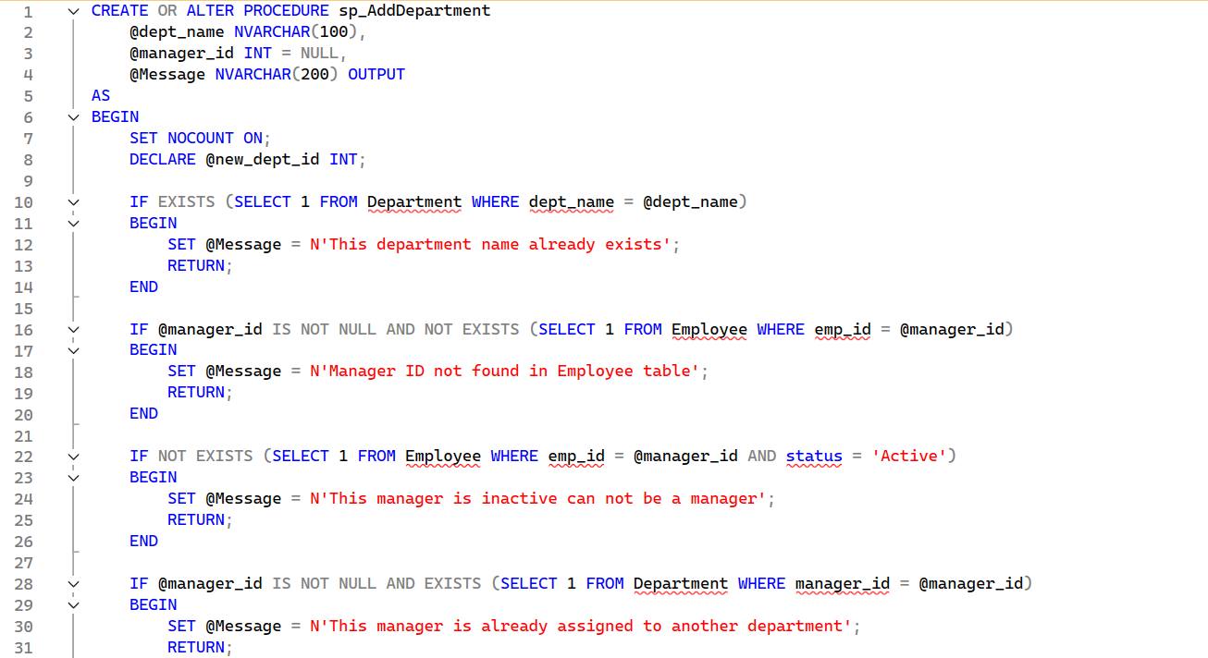

**SP_UpdateDepartment**

This stored procedure is responsible for updating an existing department’s information.  
It validates that the department exists, ensures the new department name is unique, optionally validates the manager, and then updates the department record.  
A status message is returned to indicate whether the department was updated successfully or why the operation was rejected.

**Execution flow:**

* Receives:
  + @dept_id: ID of the department to be updated.
  + @dept_name: New department name.
  + @manager_id: Optional manager employee ID.
  + @Message: Output parameter for the result message.
* Checks if the department exists in the Department table for the given @dept_id:
  + If not found, sets @Message = 'Department not found' and exits.
* Checks if the new department name is already used by another department:
  + If a different department has the same dept_name, sets  
    @Message = 'This department name is already used by another department' and exits.
* If @manager_id is not NULL:
  + Verifies that the manager exists in the Employee table:
    - If no employee is found with that ID, sets  
      @Message = 'Manager ID not found in Employee table' and exits.
  + Verifies that the manager is **active**:
    - If the manager is not active, sets  
      @Message = 'This manager is inactive can not be a manager' and exits.
  + Checks if the same manager is already assigned to another department:
    - If a department with that manager_id already exists, sets  
      @Message = 'This manager is already assigned to another department' and exits.
* If all validations pass, updates the Department record:
  + dept_name = @dept_name
  + manager_id = @manager_id  
    for the specified @dept_id.
* Sets the output message @Message to:  
  **'Department updated successfully'**.

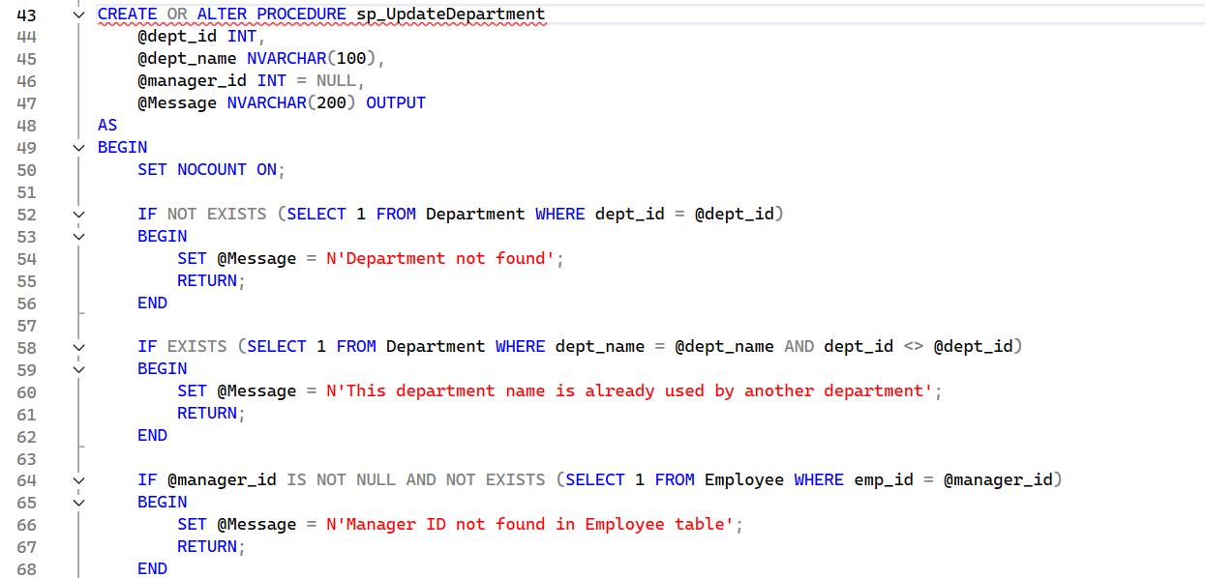

**SP_InsertEmpShift**

This stored procedure assigns an employee to a work shift.  
It validates that the employee and shift exist, checks that the employee is active, and ensures the employee is not already assigned to another shift before inserting the assignment.  
A status message is returned to indicate whether the assignment was successful or why it was rejected.

**Execution flow:**

* Receives:
  + @emp_id: Employee ID to be assigned to a shift.
  + @shift_id: Target shift ID.
  + @Message: Output parameter for the result message.
* Validates employee existence:
  + Checks the Employee table for the given @emp_id.
  + If no employee is found, sets  
    @Message = 'This employee does not exist' and exits.
* Validates employee status:
  + Checks if the employee has status = 'inactive'.
  + If inactive, sets  
    @Message = 'This employee is inactive and cannot be assigned to a shift' and exits.
* Validates shift existence:
  + Checks the Shift table for the given @shift_id.
  + If the shift does not exist, sets  
    @Message = 'This shift does not exist' and exits.
* Checks if the employee is already assigned to a shift:
  + Reads any existing shift_id from Emp_shift for that @emp_id (using TOP 1).
  + If an existing shift is found:
    - Sets @Message to:  
      "This employee is already assigned to shift number X and cannot be assigned to another shift."  
      where **X** is the existing shift ID, then exits.
* If all validations pass:
  + Inserts a new row into Emp_shift with:
    - emp_id = @emp_id
    - shift_id = @shift_id
* Sets the output message @Message to:  
  **'✅ Employee assigned to shift successfully'**.

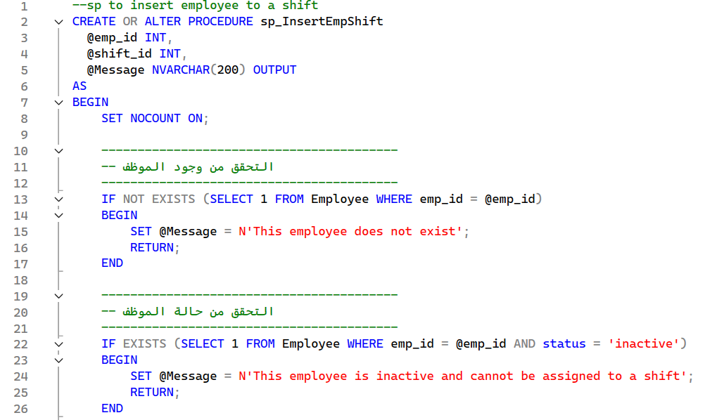

**SP_InsertNewEmployee**

This stored procedure is responsible for registering a new employee in the system.  
It validates uniqueness of SSN, phone, and email, checks the employee’s eligibility based on existing status, verifies the target department, generates a new employee ID, and finally inserts the employee record.  
A status message is returned to indicate whether the employee was added successfully or why the operation was rejected.

**Execution flow:**

* Receives the employee’s personal, contact, salary, type, and department information, along with optional @start_job, @end_job, and @status (defaults to 'Active').
* If @start_job is NULL, it sets it to today’s date using CAST(GETDATE() AS DATE).
* Checks if there is an existing employee with the same ssn:
  + If found, reads the existing status into @existing_status.
  + If @existing_status = 'Inactive', sets  
    @Message = 'This Employee cannot be re-hired because he/she is inactive' and exits.
  + If @existing_status = 'Active', sets  
    @Message = 'This Employee is already working with us' and exits.
* Checks for duplicate phone number:
  + If any employee already uses the same @phone, sets  
    @Message = 'This phone number is already used by another employee' and exits.
* Checks for duplicate email:
  + If any employee already uses the same @email, sets  
    @Message = 'This email address is already used by another employee' and exits.
* Verifies that the target department exists in the Department table for the given @dept_id:
  + If not found, sets  
    @Message = 'This department does not exist' and exits.
* Generates a new employee ID:
  + @new_emp_id = ISNULL(MAX(emp_id), 0) + 1 from the Employee table.
* Inserts a new row into Employee with:
  + emp_id = @new_emp_id
  + fname, lname, ssn, gender, birth_date
  + phone, email, salary, type
  + dept_id, start_job, end_job, status
* Sets the output message @Message to:  
  **'Employee Added Successfully'**.

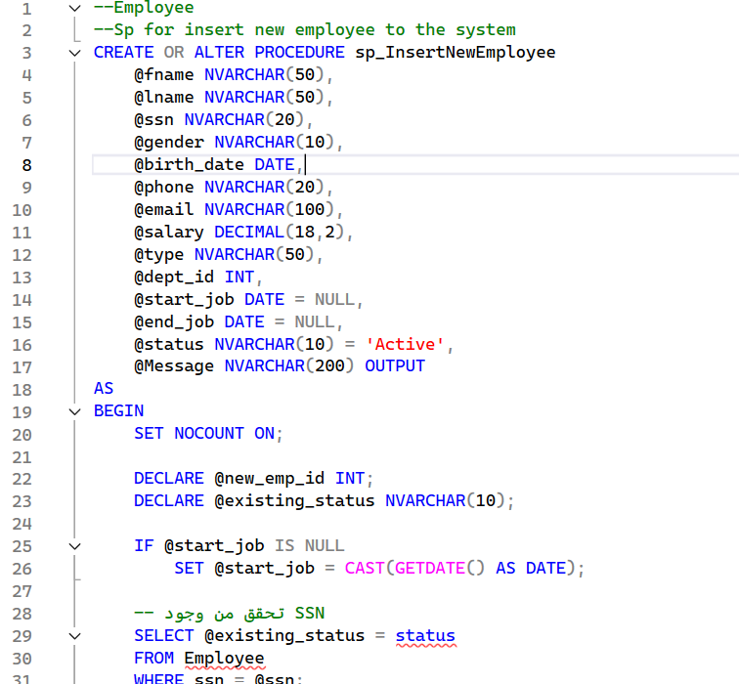

**SP_UpdateEmployee**

This stored procedure is responsible for updating an existing employee’s information in the system.  
It verifies that the employee and department exist, enforces uniqueness of phone and email, and intentionally prevents changing the employee’s SSN.  
A status message is returned to indicate whether the update was successful or why it was rejected.

**Execution flow:**

* Receives:
  + @emp_id: The employee ID to be updated.
  + Personal data: @fname, @lname, @gender, @birth_date.
  + Contact data: @phone, @email.
  + Job data: @salary, @type, @dept_id, optional @end_job, and @status (defaults to 'Active').
  + @ssn: Passed in but intentionally **not updated**.
  + @Message: Output parameter for the result message.
* Validates employee existence:
  + Checks if an employee with the given @emp_id exists in the Employee table.
  + If not found, sets @Message = 'This employee does not exist' and exits.
* Reads the current SSN:
  + Selects the existing ssn for that @emp_id into @current_ssn.
  + This preserves the existing SSN and ensures it will not be modified.
* Validates department existence:
  + Checks if a department with the given @dept_id exists in the Department table.
  + If not found, sets @Message = 'This department does not exist' and exits.
* Validates phone uniqueness:
  + Checks if any other employee (emp_id <> @emp_id) uses the same @phone.
  + If found, sets @Message = 'This phone number is already used by another employee' and exits.
* Validates email uniqueness:
  + Checks if any other employee (emp_id <> @emp_id) uses the same @email.
  + If found, sets @Message = 'This email address is already used by another employee' and exits.
* Updates the employee record (without changing SSN):
  + Updates Employee for the given @emp_id with:
    - fname = @fname, lname = @lname
    - gender = @gender, birth_date = @birth_date
    - phone = @phone, email = @email
    - salary = @salary, type = @type
    - dept_id = @dept_id, end_job = @end_job, status = @status
* Sets the output message @Message to:  
  **'Employee Updated Successfully (SSN cannot be changed)'**.

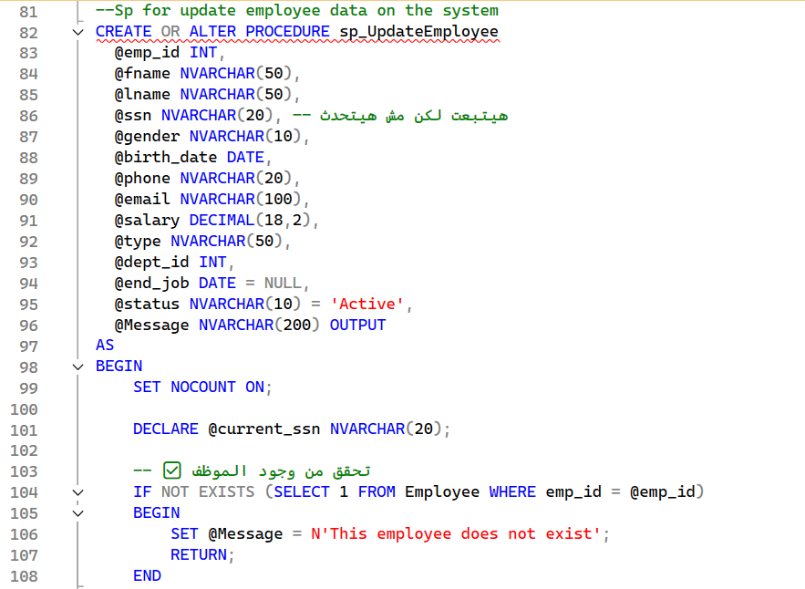

**SP_InsertAndUpdateMonthlySalary**

This stored procedure generates and updates the monthly salary records for employees for a given month.  
It inserts salary rows for all active employees who do not yet have a salary record for that month, aggregates total rewards and deductions, and then calculates the final monthly salary for each employee.

**Execution flow:**

* Receives:
  + @SalaryMonth: The target month (date used to determine month and year) for which salaries will be generated and updated.
* Inserts salary records for active employees:
  + Selects all employees from Employee where active_status = 'Active'.
  + For each active employee, checks if a Salary record already exists for that emp_id and date = @SalaryMonth.
  + If no record exists, inserts a new row into Salary with:
    - date = @SalaryMonth
    - salary = e.salary (base salary from Employee)
    - Total_reward = 0
    - Total_deduction = 0
    - emp_id = e.emp_id
* Builds a CTE for monthly rewards:
  + RewardsCTE groups the Reward table by emp_id and calculates:
    - TotalReward = SUM(amount)
  + Only includes reward rows where:
    - MONTH(date) = MONTH(@SalaryMonth) and YEAR(date) = YEAR(@SalaryMonth).
* Builds a CTE for monthly deductions:
  + DeductionsCTE groups the Deduction table by emp_id and calculates:
    - TotalDeduction = SUM(amount)
  + Only includes deduction rows where:
    - MONTH(date) = MONTH(@SalaryMonth) and YEAR(date) = YEAR(@SalaryMonth).
* Updates Salary records for the target month:
  + Joins Salary (s) with:
    - Employee (e) to get the current base salary.
    - RewardsCTE (r) to get total rewards per employee.
    - DeductionsCTE (d) to get total deductions per employee.
  + For all rows where s.date = @SalaryMonth, sets:
    - Total_reward = ISNULL(r.TotalReward, 0)
    - Total_deduction = ISNULL(d.TotalDeduction, 0)
    - salary = e.salary + ISNULL(r.TotalReward, 0) - ISNULL(d.TotalDeduction, 0)  
      (final monthly salary after rewards and deductions).

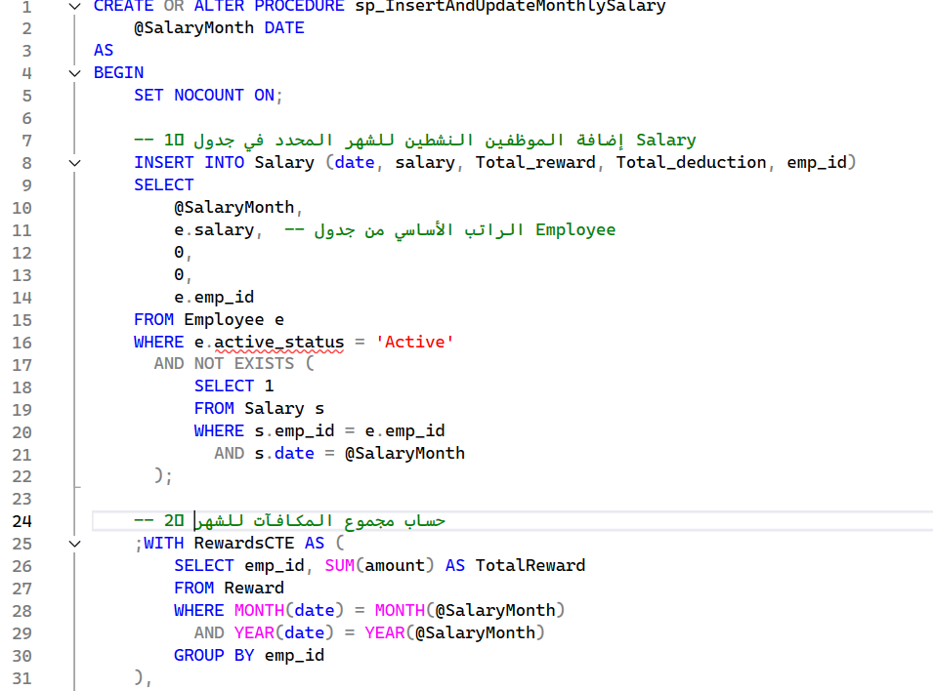

**SP_RepeatShiftAppointments**

This stored procedure automatically copies shift appointments from the last existing month into the next month.  
It detects the most recent month with shift data, calculates the following month, clears any existing appointments for that target month to avoid duplication, then recreates the shift pattern for the new month, handling differences in the number of days between months.  
A status message is returned to indicate whether the operation completed successfully or if no previous shifts were found.

**Execution flow:**

* Declares local variables to store:
  + The last year and month that have shift appointments (@LastYear, @LastMonth).
  + The new year and month to generate (@NewYear, @NewMonth).
  + The number of days in the old month (@OldDays) and new month (@NewDays).
  + Helper variables for extra days (@ExtraDay, @SecondLastDay).
* Retrieves the latest date from Shift_appointment:
  + Uses SELECT TOP 1 ... ORDER BY [date] DESC to get the most recent shift date.
  + Extracts YEAR([date]) and MONTH([date]) into @LastYear and @LastMonth.
  + If no previous shifts exist (@LastYear or @LastMonth is NULL), sets  
    @Message = 'No previous shifts found to copy.' and exits.
* Calculates the target month and year:
  + Sets @NewMonth = @LastMonth + 1 and @NewYear = @LastYear.
  + If @NewMonth > 12, wraps to the next year:
    - @NewMonth = 1
    - @NewYear = @LastYear + 1
* Determines the number of days in both months:
  + Uses EOMONTH and DATEFROMPARTS to get:
    - @OldDays = number of days in the last month.
    - @NewDays = number of days in the new month.
* Removes any existing shift appointments for the target month:
  + Executes DELETE FROM Shift_appointment for rows where:
    - YEAR([date]) = @NewYear
    - MONTH([date]) = @NewMonth
  + This prevents duplicate or conflicting data if the procedure is rerun.
* Inserts shift appointments for all common days between the two months:
  + Inserts into Shift_appointment (shift_id, shift_type, [date], start_time, end_time) by selecting from the last month where:
    - YEAR([date]) = @LastYear
    - MONTH([date]) = @LastMonth
    - DAY([date]) <= @NewDays
  + The new date is built using:
    - DATEFROMPARTS(@NewYear, @NewMonth, DAY([date]))
* Handles extra days in the new month (e.g. going from 30 to 31 days):
  + If @NewDays > @OldDays:
    - Sets:
      * @ExtraDay = @OldDays + 1
      * @SecondLastDay = @OldDays - 1
    - Inserts shift appointments for the extra day (@ExtraDay) in the new month by copying the pattern from the **second last day** of the previous month (DAY([date]) = @SecondLastDay).
* At the end of the process, sets:
  + @Message = 'Shift appointments have been repeated successfully for the next month.'.

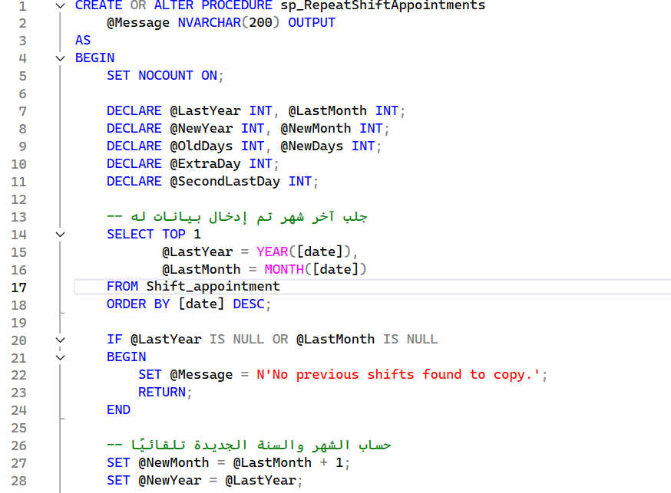

**SP_ProcessPrescriptionSale**

This stored procedure processes the sale of a prescription.  
It validates the prescription and its drugs, matches requested drugs with pharmacy stock, handles partial sales when stock is insufficient, updates inventory, triggers auto-reorder for low-stock drugs, generates an invoice, and returns a message with the total amount and detailed warnings.

**Execution flow:**

* Validates prescription:
  + Checks that a prescription with the given @PrescriptionID exists in Prescription.
  + Ensures the prescription has listed drugs (drug_name IS NOT NULL).
  + If either check fails, sets an error @Message and exits.
* Loads requested drugs:
  + Uses the table-valued parameter @Drugs (list of drugs and requested quantities from the pharmacist).
  + Inserts its content into a temp table @Temp with columns:  
    drug_name, req_qty, and placeholders for drug_id, sold_qty, price, total_price.
* Validates that requested drugs belong to the prescription:
  + Ensures every drug in @Temp exists in the original prescription (matching by trimmed, lowercased drug_name).
  + If any requested drug is not listed in the doctor’s prescription, sets @Message and exits.
* Maps requested drugs to pharmacy stock:
  + Joins @Temp with Pharmacy_drugs by drug_name.
  + For each row, sets:
    - drug_id and price from Pharmacy_drugs.
    - sold_qty based on availability:
      * If P.quantity >= req_qty → sells full req_qty.
      * If 0 < P.quantity < req_qty → sells available P.quantity.
      * If P.quantity <= 0 → sells 0.
    - total_price = price * sold_qty.
* Inserts sold drugs into Prescription_drugs:
  + Inserts rows only where sold_qty > 0, with:
    - Prescription_id = @PrescriptionID
    - drug_id
    - quantity = sold_qty
    - total_price.
* Updates pharmacy inventory:
  + Decreases Pharmacy_drugs.quantity by sold_qty for all sold drugs (sold_qty > 0).
* Auto-reorder for low-stock drugs:
  + Sets @today = GETDATE().
  + Inserts into Drug_Purchases for drugs that:
    - Are in Pharmacy_drugs and appear in @Temp.
    - Have quantity < 10 after sale.
    - Have sold_qty > 0.
    - Do **not** already have a purchase record today.
  + For each such drug, inserts:
    - Drug_Name
    - Quantity = 50 (default purchase quantity)
    - Unit_Cost = price * 0.7 (purchase cost = 70% of selling price)
    - Purchase_Date = @today.
* Updates stock based on today’s purchases:
  + Uses a MERGE on Pharmacy_drugs with today’s Drug_Purchases:
    - If drug exists in Pharmacy_drugs:
      * Increases Quantity by the purchased quantity.
      * Updates price to the purchase Unit_Cost.
    - If drug does not exist:
      * Inserts a new row into Pharmacy_drugs with Drug_Name, Quantity, Price = Unit_Cost.
* Builds auto-purchase warning text:
  + Collects a list of drugs purchased today (from Drug_Purchases) whose stock is now at or above 10.
  + For each, appends a line to @AutoAdded with drug name, quantity, and date.
  + If any were found, appends a section to @Warnings:
    - "⚠ Auto purchase executed for low-stock drugs:" + bullet list.
* Calculates total invoice amount:
  + Sums total_price from @Temp for rows where sold_qty > 0 into @TotalInvoice.
* Builds detailed stock warnings:
  + Joins @Temp with Pharmacy_drugs and appends messages to @Warnings per drug, such as:
    - Sold partially and now stock is zero.
    - Sold partially and some stock remains.
    - Low stock warning (quantity <= 10).
    - Completely out of stock and no sale was processed.
* Creates invoice (if any sale happened):
  + If @TotalInvoice > 0, inserts into Invoice:
    - Gets reservation_id and p_id from Prescription for @PrescriptionID.
    - Sets:
      * reservation_type = 'Prescription'
      * date = GETDATE()
      * payment_method = 'Cash'
      * paid_money = @TotalInvoice
      * emp_id = @emp_id (employee processing the sale).
* Final output message:
  + Builds @Message as:
    - "Sale completed successfully."
    - "Total Invoice Amount: <amount>"
    - Optional "Warnings:" section followed by all accumulated @Warnings.

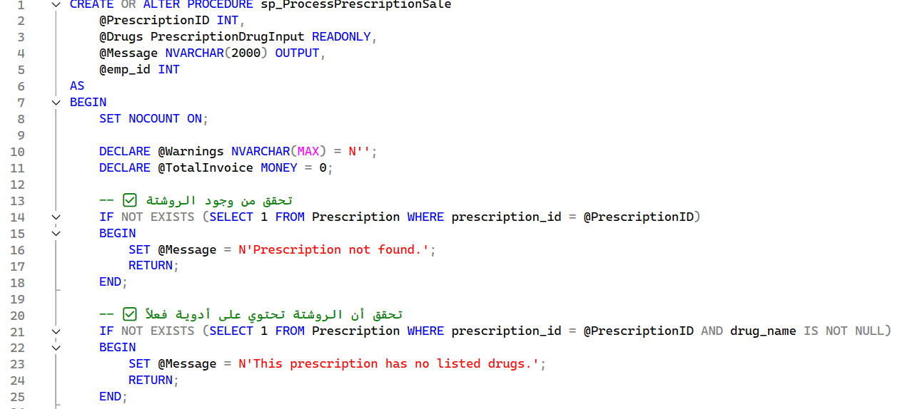

**SP_AddDrugPurchase**

This stored procedure registers a new drug purchase and adds the drug to the pharmacy stock.  
It prevents adding duplicate drugs, records the purchase in the Drug_Purchases table with today’s date, creates a new entry in Pharmacy_drugs with a generated drug ID, and calculates an initial selling price as a markup over the purchase cost.  
A detailed status message is returned with key information about the added drug.

**Execution flow:**

* Receives:
  + @Drug_Name: Drug name to be added.
  + @Quantity: Purchased quantity.
  + @Unit_Cost: Purchase cost per unit.
  + @prod_date: Production date.
  + @exp_date: Expiry date.
  + @Message: Output parameter for the result message.
* Checks for existing drug in pharmacy:
  + Searches Pharmacy_drugs for an existing row where LOWER(drug_name) = LOWER(@Drug_Name).
  + If found, sets:
    - @Message = '⚠ The drug "<name>" already exists in the pharmacy.'
    - Then exits without inserting anything.
* Inserts a purchase entry:
  + Inserts into Drug_Purchases:
    - Drug_Name = @Drug_Name
    - Quantity = @Quantity
    - Unit_Cost = @Unit_Cost
    - Purchase_Date = GETDATE() (today’s date).
* Generates a new drug_id:
  + Calculates:
  + SELECT @NewDrugID = ISNULL(MAX(drug_id), 0) + 1 FROM Pharmacy_drugs;
* Inserts the drug into Pharmacy_drugs:
  + Inserts:
    - drug_id = @NewDrugID
    - drug_name = @Drug_Name
    - quantity = @Quantity
    - price = @Unit_Cost * 1.3 (approx. 30% markup as selling price)
    - prod_date = @prod_date
    - exp_date = @exp_date
* Builds a detailed success message:
  + Sets @Message to a multi-line text containing:
    - Confirmation that the drug was added successfully.
    - The quantity.
    - Purchase price (@Unit_Cost).
    - Calculated selling price (@Unit_Cost * 1.3).
    - Purchase date formatted as dd/MM/yyyy (CONVERT(…, 103)).

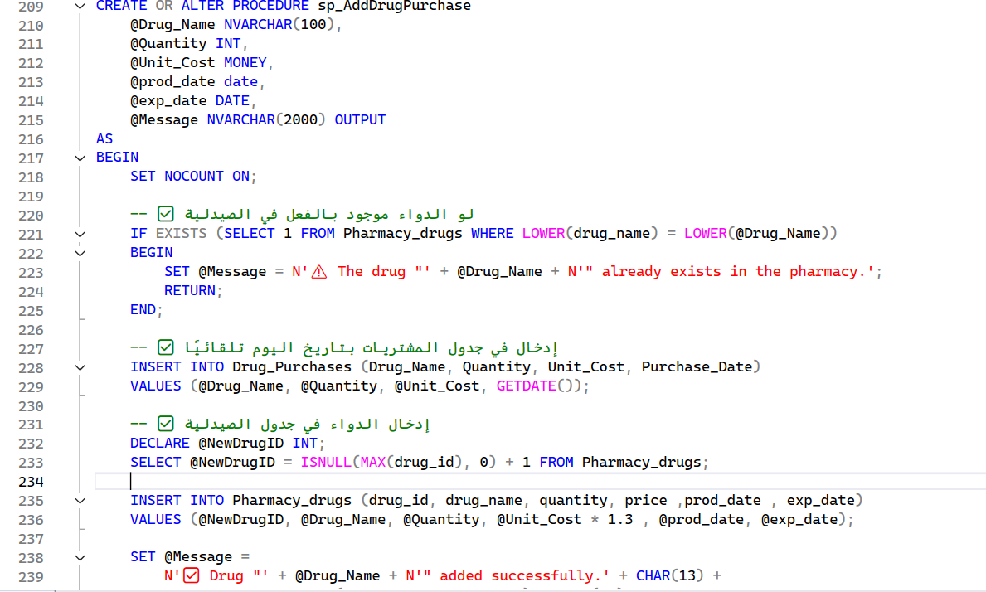

**SP_ExpiryAlert**

This stored procedure returns a list of drugs that are approaching their expiry date.  
It selects all drugs whose expiry date is between today and three months from now, and calculates how many days are left until each one expires.

**Execution flow:**

* Sets NOCOUNT ON to avoid extra row count messages.
* Selects from Pharmacy_drugs the following columns:
  + drug_id
  + drug_name
  + quantity
  + exp_date
  + Days_to_Expire = DATEDIFF(DAY, GETDATE(), exp_date) (number of days until expiry).
* Filters rows where:
  + exp_date <= DATEADD(MONTH, 3, GETDATE()) → expires within the next 3 months.
  + exp_date >= GETDATE() → not already expired.
* Orders the result by exp_date ascending so that the earliest expiring drugs appear first.

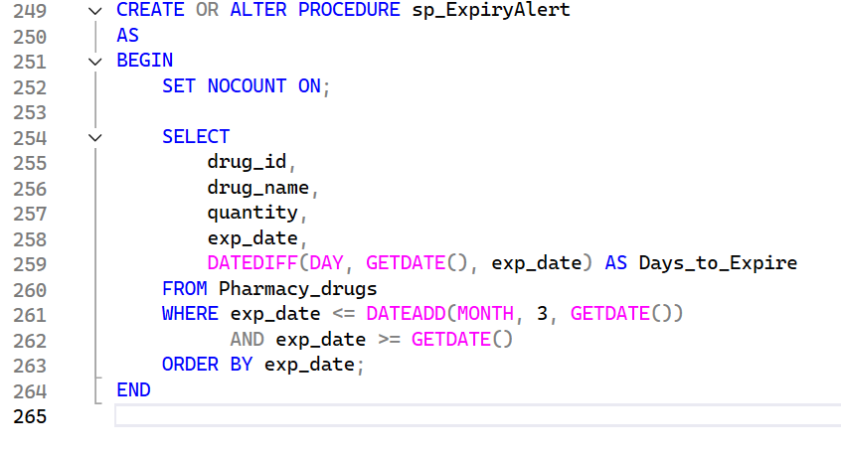

**SP_surgery_reservation_auto**

This stored procedure automatically schedules a surgery for a patient.  
It validates the doctor and date, finds available operating and recovery rooms, assigns staff and receptionist, creates all related reservations, and generates a single invoice with detailed items.

**Execution flow (summary):**

* Validates:
  + Doctor exists and is a consultant_doctor.
  + Surgery date is not in the past and not on Friday.
  + Surgery definition (surgery_name) exists in Surgery.
* Selects:
  + An available **receptionist** currently in shift.
  + An available **operating room** for the given date and next free time (with preparation buffer).
  + An available **staff** member (or uses @stuff_id_input if provided) with no time conflict.
  + An available **recovery room** with the least load around the surgery date.
* Checks there is **no overlapping surgery** for the same doctor or patient at the calculated time.
* Creates:
  + A record in Surgery_reservation (date, time, doctor, patient, OR room, staff, surgery price).
  + Two records in Room_reservation (operating room period + recovery room period).
  + Updates Room_Status for the used rooms to reserved.
* Calculates total cost (surgery + OR room + recovery room), creates an Invoice, and inserts three lines in Invoice_Details for:
  + Surgery
  + Operating room
  + Recovery room
* On success: commits the transaction and returns a message with date, time, OR room, recovery room, and reservation ID.
* On error: rolls back and returns the error message in @Message.

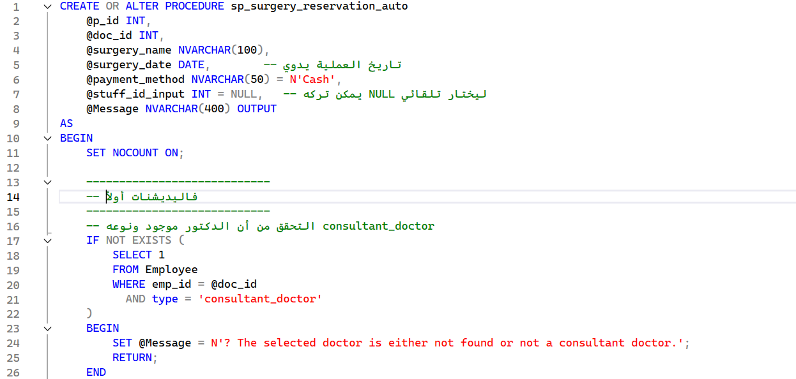

**SP_cancel_surgery**

This stored procedure cancels a scheduled surgery reservation.  
It updates the surgery and related room reservations, frees rooms when applicable, and removes related invoice details and empty invoices.

**Execution flow (summary):**

* Fetches the surgery info (surgery_date, start_time, p_id) for the given @reservation_id.
  + If not found → sets message *"Reservation not found."* and exits.
* Updates Surgery_reservation:
  + status = 'canceled'
  + paid_money = 0.
* Updates related Room_reservation rows for the same patient from the surgery date onward:
  + Only those with status reserved_for_surgery / reserved_for_recovery.
  + Sets status = 'canceled' and paid_money = 0.
* If the surgery is in the future (or later today), updates Room_Status for these rooms back to available.
* Deletes Invoice_Details rows linked to this reservation_id.
* Deletes any Invoice that no longer has details in Invoice_Details.
* Uses an explicit transaction with TRY/CATCH:
  + On success → COMMIT and returns a success message.
  + On error → ROLLBACK and returns the error text in @Message.

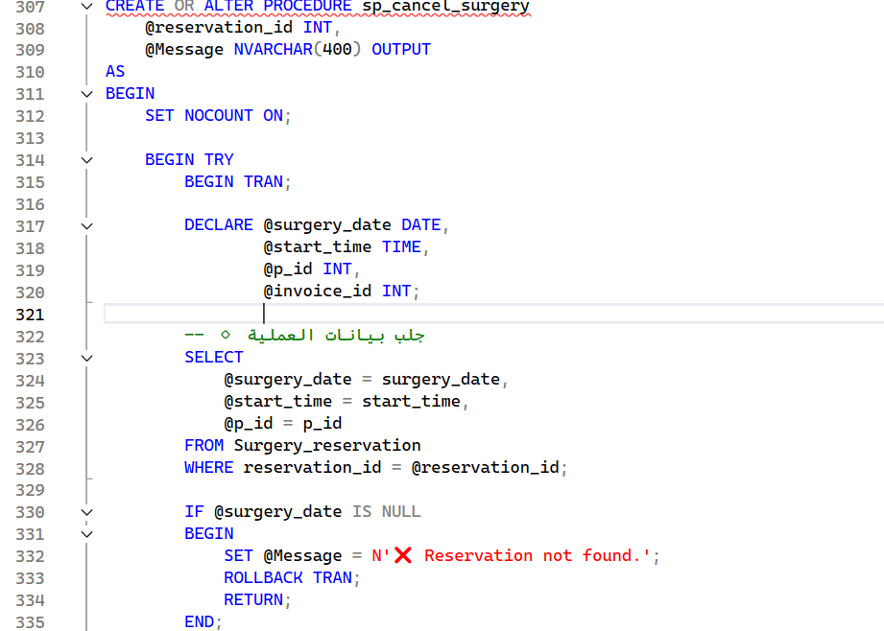

**SP_insert_room**

This stored procedure inserts a new room into the system.  
It checks whether the room type already exists and, if so, reuses its existing daily price.  
If the room type is new, it requires a valid price_per_day to be provided.  
After inserting the new room into the Room table, it also initializes its status as Available in the Room_Status table.  
A message is returned through the @Message output parameter indicating success or error details.

**Execution flow:**

* Receives:
  + @room_type: The type of the room to insert (e.g. “surgery”, “recovery”, “standard”).
  + @price_per_day: Optional daily price; required only if this is a new room type.
  + @Message: Output parameter used to return a status message.
* Attempts to retrieve an existing price for the given room type:
  + Queries the Room table for any record where room_type matches @room_type (case-insensitive).
  + If a matching room type is found, its price_per_day is stored in @existing_price.
* Handles pricing logic:
  + If @existing_price is **not** NULL (room type already exists):
    - Sets @price_per_day to @existing_price, reusing the existing price for this room type.
  + If @existing_price **is** NULL (new room type):
    - Validates that @price_per_day is provided and greater than zero.
    - If @price_per_day is NULL or <= 0, sets  
      @Message = 'Error: New room type detected. Please provide a valid price_per_day value.'  
      and returns without inserting a room.
* Generates a new room ID:
  + Calculates @room_id as MAX(room_id) + 1 from the Room table (or 1 if the table is empty).
* Inserts the new room:
  + Inserts a record into Room with:
    - room_id = @room_id
    - room_type = @room_type
    - price_per_day = @price_per_day
* Inserts the initial room status:
  + Inserts a record into Room_Status with:
    - room_id = @room_id
    - status = 'Available'
* Success handling:
  + On successful insert, sets @Message to a confirmation message that includes the room type and its price.
* Error handling:
  + The procedure is wrapped in a TRY...CATCH block.
  + If any error occurs inside the TRY, the CATCH block sets @Message to:
    - 'Error: ' + ERROR_MESSAGE()  
      so that the caller receives the underlying SQL error text.

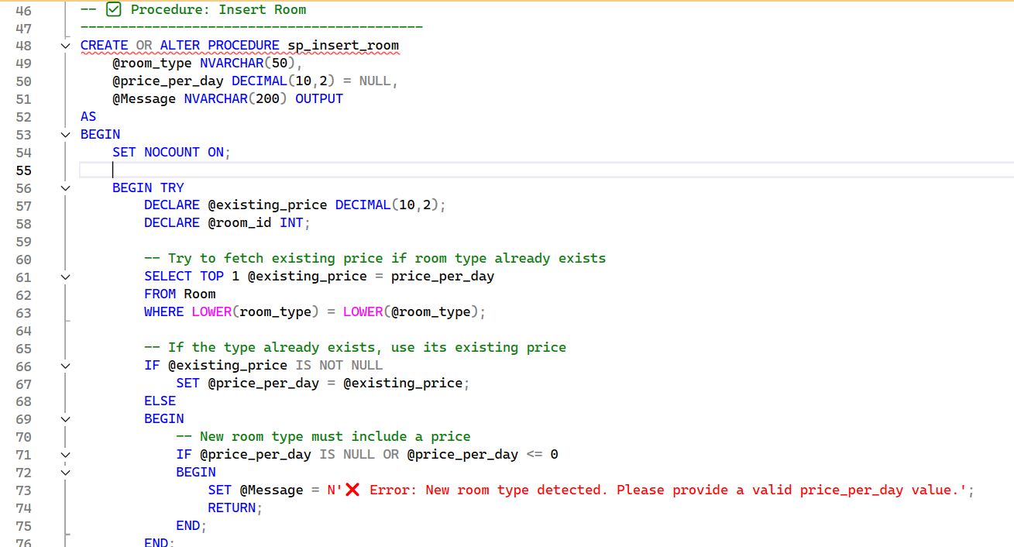

**SP_update_room**

This stored procedure updates the type of an existing room and automatically adjusts its daily price based on the target room type.  
It first verifies that the room exists, then checks if the new room type already exists in the Room table. If the type is known, it reuses the corresponding price_per_day. If the type does not exist, the update is blocked and an error message is returned.  
All status messages are returned through the @Message output parameter.

**Execution flow**

* **Input parameters**
  + @room_id: Identifier of the room to be updated.
  + @new_type: Target room type to be assigned to the room.
  + @Message: Output parameter used to return success or error messages.
* **Room existence validation**
  + Checks the Room table for a record with the given @room_id.
  + If no such room exists:
    - Sets @Message to indicate that the room was not found.
    - Exits the procedure without performing any update.
* **Resolve price for the new room type**
  + Declares a local variable @new_price (DECIMAL(10,2)).
  + Queries the Room table for any room whose room_type matches @new_type (case-insensitive).
  + If a matching room type is found:
    - Stores its price_per_day value in @new_price.
  + If no room with the specified type exists:
    - Sets @Message to indicate that the room type is unknown and that a room with this type must be inserted first.
    - Exits the procedure without updating the room.
* **Update room type and price**
  + If @new_price has been resolved successfully:
    - Executes an UPDATE on the Room table for the target @room_id:
      * room_type is set to @new_type.
      * price_per_day is set to @new_price.
    - Sets @Message to indicate that the room type and price were updated successfully.
* **Error handling**
  + The logic is wrapped in a TRY...CATCH block.
  + If any runtime error occurs:
    - The CATCH block captures the error using ERROR_MESSAGE().
    - @Message is set to a generic error text that includes the underlying SQL error message.

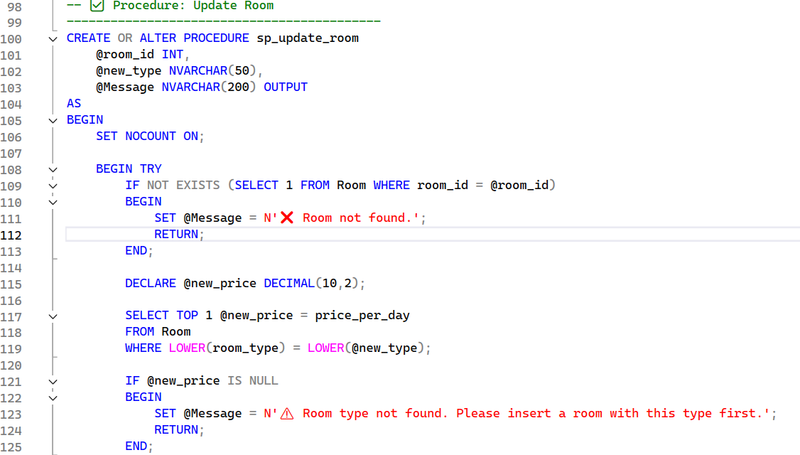

**SP_room_reservation**  
This stored procedure creates a room reservation for a patient.  
It validates that the patient exists, locates an available receptionist currently on duty, selects the first available room of the requested type, creates a room reservation, and updates the room status to “Reserved”.  
A detailed status message is returned through the @Message output parameter, including the room ID and reservation ID on success.

**Execution flow**

* **Input parameters**
  + @p_id: Patient ID for whom the room is being reserved.
  + @room_type: Desired room type (e.g. “standard”, “recovery”, “surgery”).
  + @Message: Output parameter used to return success or error messages.
* **Local variables**
  + @receptionist_id: Will hold the ID of the receptionist handling the reservation.
  + @room_id: Will hold the selected room ID.
  + @checkin_date: Initialized to GETDATE() (today’s date).
* **Patient validation**
  + Checks the Patient table for a record with p_id = @p_id.
  + If no patient is found:
    - Sets @Message to indicate an invalid patient ID.
    - Returns without creating a reservation.
* **Select an available receptionist on duty**
  + Joins Employee, Emp_shift, and Shift_appointment to find employees of type 'Receptionist' whose current time (CAST(GETDATE() AS TIME)) falls between their shift start_time and end_time.
  + Takes the first matching receptionist and stores their emp_id in @receptionist_id.
  + If no receptionist is found:
    - Sets @Message to indicate that no receptionist is currently available.
    - Returns without creating a reservation.
* **Select an available room of the requested type**
  + Joins Room and Room_Status to find rooms where:
    - room_type matches @room_type (case-insensitive).
    - status (from Room_Status) is 'available' (case-insensitive).
  + Orders by room_id and selects the first available room, storing its room_id in @room_id.
  + If no room of the requested type is available:
    - Sets @Message to indicate that there are no available rooms of the selected type.
    - Returns without creating a reservation.
* **Insert the room reservation**
  + Inserts a new record into Room_reservation with:
    - p_id = @p_id
    - room_id = @room_id
    - emp_id = @receptionist_id
    - checkin = @checkin_date
  + After insertion, retrieves the most recent reservation_id for that room_id (ordered by reservation_id descending) and stores it in @reservation_id.
* **Update room status**
  + Updates Room_Status for the selected room_id, setting:
    - status = 'Reserved'
* **Success message**
  + On successful insert and status update, sets @Message to a message indicating:
    - The room ID used.
    - The created reservation ID.
* **Error handling**
  + The procedure is wrapped in a TRY...CATCH block.
  + If any runtime error occurs inside the TRY block:
    - The CATCH block captures the error using ERROR_MESSAGE().
    - Sets @Message to a generic error string including the underlying SQL error message.

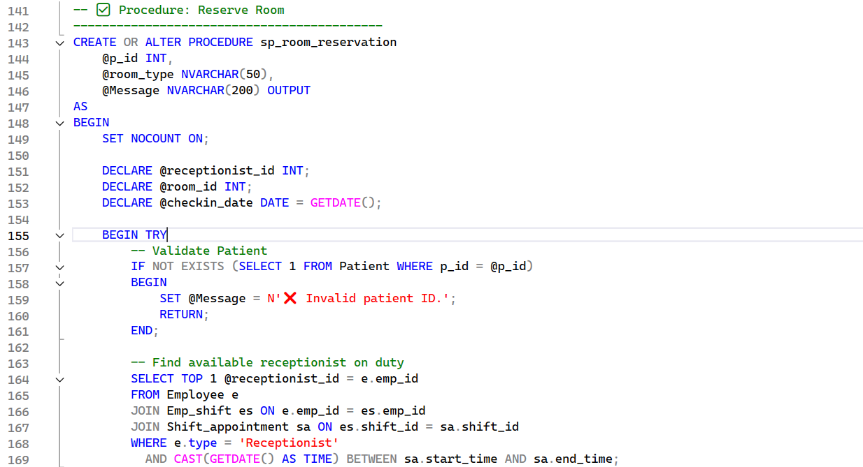

**SP_room_checkout**

This stored procedure handles the checkout process for a room reservation.  
It validates that a receptionist is currently on duty, loads the reservation and room information, validates the checkout date, calculates the total charge, updates the reservation and room status, and creates an invoice.

**Execution flow**

* Validates that there is an active receptionist on shift; if none is found, the procedure exits with an error message.
* Loads room reservation and room details (room_id, check-in date, price per day, patient, room type) for the given @reservation_id.
* Ensures that the provided @checkout date is not earlier than the existing checkin date.
* Calls dbo.fn_calculate_room_payment(@checkin, @checkout, @price_per_day) to compute the total amount to be paid.
* Updates Room_reservation with the checkout date and calculated paid_money.
* Sets the corresponding room’s status in Room_Status back to Available.
* Generates a new invoice_id and inserts a row into Invoice with:
  + reservation_id, reservation_type = 'Room - ' + @room_type, date, payment method, total paid, patient, and receptionist.
* Returns a success message including the total paid amount, or an error message from the CATCH block if an exception occurs.

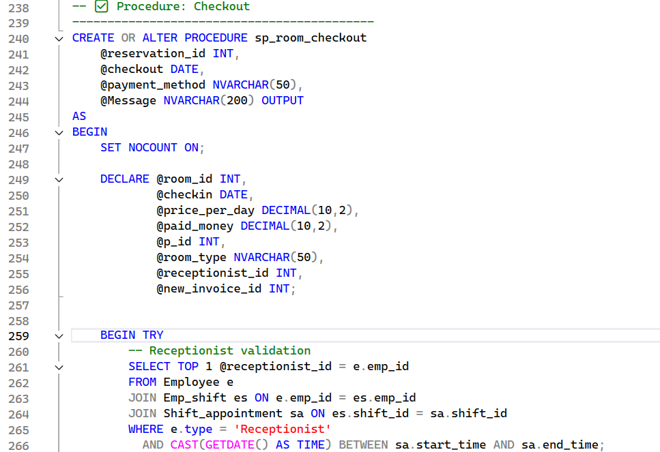

Top of Form

Bottom of Form

**SP_AddLabReservation_Multi**

This stored procedure creates a lab invoice and multiple lab reservations for a given patient in a single operation.  
It validates the patient, selects a lab doctor on duty and a receptionist currently in shift, validates the list of requested tests against the configured lab tests, calculates the total price, creates a single invoice, and then creates individual lab reservations and test reservations for each test. A summary message is returned through the @msg output parameter.

**Execution flow**

* Input parameters:
  + @p_id: Patient ID for whom the lab tests are requested.
  + @payment_method: Payment method for the invoice (defaults to 'Cash').
  + @Tests: A read-only table-valued parameter of type TestListType containing the list of requested test names.
  + @msg: Output parameter used to return a status message.
* Initialization:
  + Reads the current weekday name into @Today using DATENAME(WEEKDAY, GETDATE()).
  + Declares placeholders for:
    - @Receptionist_ID (current receptionist on shift),
    - @lab_doctorID (lab doctor on duty),
    - @invoice_id (newly created invoice),
    - @TotalPrice (total price of all tests).
* Patient validation:
  + Checks the Patient table for a record with p_id = @p_id.
  + If the patient does not exist:
    - Sets @msg to an error message and returns.
* Select lab doctor on duty:
  + Selects a lab doctor by joining Employee with Doctor_appointments, filtered by:
    - dept_id = 13 (lab department),
    - Doctor_appointments.[day] = @Today.
  + Stores the doctor’s emp_id in @lab_doctorID.
  + If no lab doctor is found for the current day:
    - Sets @msg to indicate that no lab doctor is available and returns.
* Select current receptionist:
  + Joins Employee, Emp_shift, and Shift_appointment to find an employee of type 'Receptionist' whose current time is within their shift window:
    - Handles both normal shifts (start_time < end_time) and overnight shifts (start_time > end_time).
  + Stores the result in @Receptionist_ID.
  + If no receptionist is available:
    - Sets @msg to an error message and returns.
* Validate test names:
  + Checks each row in @Tests against Lab_tests by test_name.
  + If any test name in @Tests does not exist in Lab_tests:
    - Sets @msg to "One or more test names are invalid." and returns.
* Calculate total price:
  + Joins @Tests with Lab_tests and computes:
    - @TotalPrice = SUM(lt.price) over all requested tests.
* Insert invoice header:
  + Inserts a new row into Invoice with:
    - date = GETDATE()
    - paid_money = @TotalPrice
    - payment_method = @payment_method
    - p_id = @p_id
    - emp_id = @Receptionist_ID
  + Uses SCOPE_IDENTITY() to store the created invoice ID into @invoice_id.
* Cursor over requested tests:
  + Declares local variables: @test_name, @price, @test_id, @reservation_id.
  + Opens a cursor that selects test_name, price, and test_id from @Tests joined to Lab_tests.
  + For each test in the cursor:
    - Checks for duplicate same-day booking:
      * Looks in Lab_reservation for an existing row where:
        + p_id = @p_id,
        + test_name = @test_name,
        + the reservation date (cast to DATE) equals today.
      * If such a record exists:
        + Sets @msg to "Patient already booked "<test_name>" today.",
        + Closes and deallocates the cursor, and returns.
    - Inserts a new lab reservation into Lab_reservation with:
      * date = GETDATE()
      * paid_money = @price
      * p_id = @p_id
      * test_name = @test_name
      * emp_id = @lab_doctorID
    - Captures the new reservation_id using SCOPE_IDENTITY().
    - Inserts a record into Test_reserve with:
      * test_id, reservation_id, and test_result = NULL.
    - Inserts a record into Invoice_details with:
      * invoice_id = @invoice_id
      * reservation_id
      * reservation_type = 'Lab'
      * Process_id = @test_id
      * unit_price = @price
      * quantity = 1.
  + After finishing all tests:
    - Closes and deallocates the cursor.
* Final message:
  + On success, sets @msg to a message indicating that the lab invoice was created successfully, including:
    - The total amount (@TotalPrice)
    - The generated invoice ID (@invoice_id).

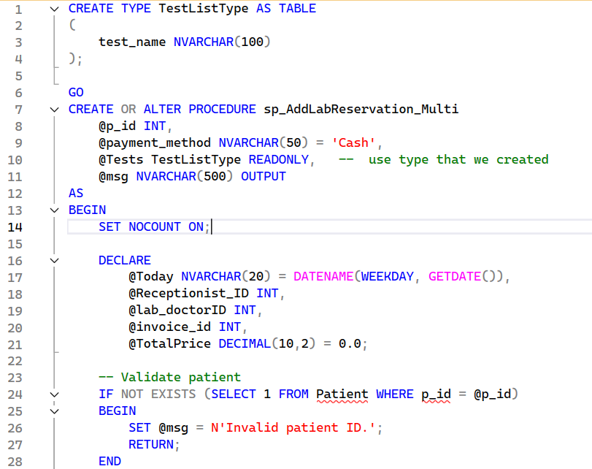Top of Form





**SP_AddLabReservation**

This stored procedure creates a single lab reservation for a patient for a specific test.  
It validates the lab test, prevents duplicate same-day bookings for the same patient and test, enforces that the paid amount matches the configured test price, selects a lab doctor on duty and a receptionist in the current shift, inserts the reservation and test reference, and creates an invoice linked to the reservation.

**Execution flow**

* Validates that the requested lab test exists in Lab_tests by test_name.  
  If no matching test is found, the procedure returns with an error message.
* Retrieves the test ID and configured price (test_id, price) for the given test_name from Lab_tests.
* Ensures the patient has not already booked the same test on the same day:  
  checks Lab_reservation for an existing record with the same p_id, test_name, and today’s date.  
  If such a reservation exists, the procedure returns with an error message.
* Validates the paid amount:  
  compares @paid_money to the configured @price.  
  If they do not match, the procedure returns an error indicating the correct price.
* Selects a lab doctor on duty:  
  chooses a doctor from Employee joined to Doctor_appointments where dept_id = 13 (lab department) and Doctor_appointments.[day] matches the current weekday.
* Selects a receptionist currently in shift:  
  joins Employee, Emp_shift, and Shift_appointment to find an employee of type 'Receptionist' whose current time falls within their shift window.
* Inserts a new lab reservation into Lab_reservation with:
  + date = GETDATE()
  + paid_money = @paid_money
  + p_id = @p_id
  + test_name = @test_name
  + emp_id = @lab_doctorID (the lab doctor handling the test)

The generated reservation_id is captured using SCOPE_IDENTITY().

* Inserts a corresponding entry into Test_reserve:
  + test_id from Lab_tests
  + reservation_id from the newly created Lab_reservation
  + test_result = NULL (placeholder for future results)
* Inserts an invoice row into Invoice linked to this lab reservation with:
  + reservation_id = the generated lab reservation ID
  + reservation_type = 'Lab'
  + date = GETDATE()
  + payment_method = @payment_method
  + paid_money = @paid_money
  + p_id = @p_id
  + emp_id = @lab_doctorID
* Returns a success message in @msg including the newly created reservation_id.

Top of Form

Bottom of Form

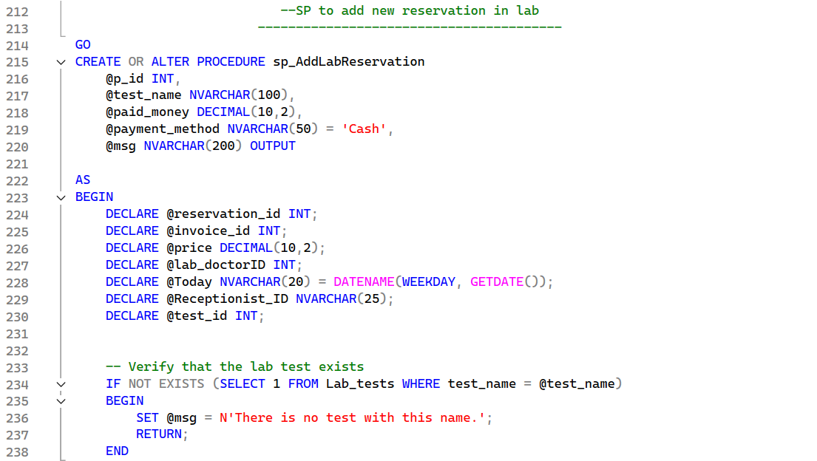

**SP_AddRadioReservation**

This stored procedure creates a radiology reservation for a patient for a specific radiology test.  
It validates that the radiology test exists, prevents duplicate same-day bookings for the same patient and test, enforces that the paid amount matches the configured test price, selects a radiology doctor on duty and a receptionist in the current shift, creates the reservation, links it to the underlying radiology definition, and generates an invoice.

**Execution flow**

* Validates that the requested radiology test exists in the Radiology table by rad_name.  
  If no matching test is found, the procedure returns with an error message.
* Retrieves the radiology ID and price:  
  selects rad_id and price for the given @rad_name from Radiology into local variables.
* Checks for duplicate same-day booking:  
  queries Radio_reservation to see if the same patient (@p_id) has already booked the same @rad_name on today’s date.  
  If such a reservation exists, the procedure returns with an error message.
* Validates the paid amount:  
  compares @paid_money to the configured @price.  
  If they are not equal, the procedure returns with an error containing the correct price.
* Selects a radiology doctor on duty:  
  picks a doctor from Employee joined with Doctor_appointments where:
  + dept_id = 14 (radiology department)
  + Doctor_appointments.[day] equals today’s weekday name (DATENAME(WEEKDAY, GETDATE())).
* Selects a receptionist currently in shift:  
  joins Employee, Emp_shift, and Shift_appointment to find an employee of type 'Receptionist' whose current time falls between start_time and end_time of their shift.
* Inserts the radiology reservation into Radio_reservation with:
  + date = GETDATE()
  + paid_money = @paid_money
  + p_id = @p_id
  + rad_name = @rad_name
  + emp_id = @radio_doctorID.  
    The generated reservation_id is captured using SCOPE_IDENTITY().
* Inserts a corresponding record into Rad_reserve:
  + rad_id from Radiology
  + reservation_id from the newly created Radio_reservation
  + test_result = NULL as an initial placeholder.
* Inserts an invoice row into Invoice linked to this radiology reservation with:
  + reservation_id = the created reservation ID
  + reservation_type = 'Radio'
  + date = GETDATE()
  + payment_method = @payment_method
  + paid_money = @paid_money
  + p_id = @p_id
  + emp_id = @radio_doctorID.
* Returns a success message in @msg indicating that the radiology reservation was added successfully and including the generated reservation_id.

Top of Form

Bottom of Form

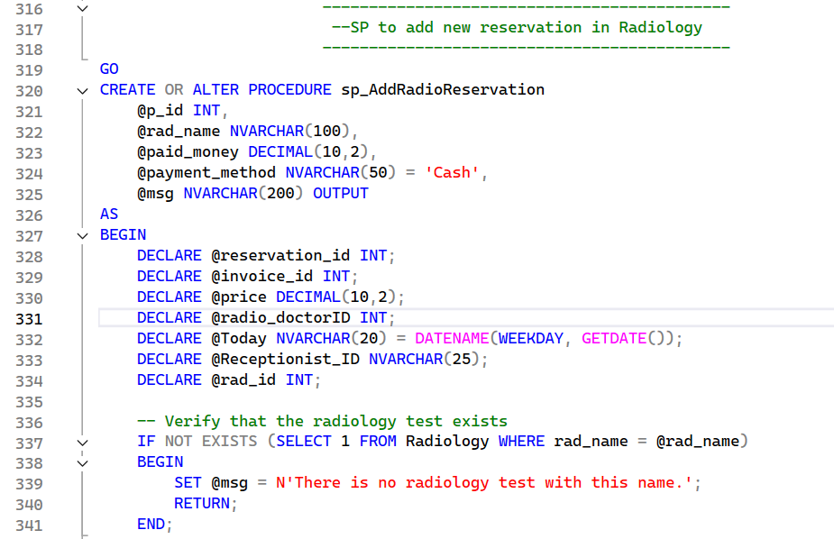

**SP_add_doctor_reservation**

This stored procedure creates a clinic appointment reservation for a patient and generates the corresponding invoice and invoice details.  
It selects an available doctor and receptionist based on the current day and time, validates the department and reservation capacity, and then records the reservation and billing information.

**Execution flow**

* Determines the current weekday name using DATENAME(WEEKDAY, GETDATE()) and stores it in @today.
* Selects an available doctor from Doctor_appointments for the current day and time:
  + Finds the first record where:
    - [day] = @today
    - the current time is between shift_start and shift_end.
  + Retrieves:
    - @doctor_id = emp_id
    - @doctor_price = examination_price.
  + If no doctor is found, returns with an error message.
* Validates that the requested department exists in Doctor_appointments:
  + Checks for any row with dept_id = @dept_id.
  + If not found, returns with an error message indicating that the department does not exist.
* Selects a receptionist currently on shift:
  + Joins Employee, Emp_shift, and Shift_appointment and filters for:
    - e.type = 'Receptionist'
    - current time between sa.start_time and sa.end_time
    - sa.date is equal to today’s date.
  + Stores the result in @receptionist_id.
  + If no receptionist is available, returns with an error message.
* Checks the doctor’s current daily reservation count:
  + Counts rows in appointment_reservation where:
    - doctor_id = @doctor_id
    - CAST(date_time AS DATE) = CAST(GETDATE() AS DATE).
  + If the count is **20 or more**, returns an error that the maximum reservation limit has been reached for this doctor.
* Generates new identifiers:
  + @new_reservation_id is set to MAX(reservation_id) + 1 from appointment_reservation.
  + @new_invoice_id is set to MAX(invoice_id) + 1 from Invoice.
* Inserts the appointment reservation into appointment_reservation:
  + reservation_id = @new_reservation_id
  + p_id = @p_id
  + dept_id = @dept_id
  + doctor_id = @doctor_id
  + date_time = GETDATE()
  + paid_money = @doctor_price
  + receptionist_id = @receptionist_id.
* Inserts the invoice header into Invoice:
  + invoice_id = @new_invoice_id
  + paid_money = @paid_total (intended to hold the final amount, typically equal to @doctor_price)
  + date = GETDATE()
  + payment_method = @payment_method
  + p_id = @p_id
  + emp_id = @receptionist_id.
* Inserts the invoice detail into Invoice_Details:
  + invoice_id = @new_invoice_id
  + reservation_id = @new_reservation_id
  + reservation_type = 'Clinic'
  + Process_id = @doctor_id
  + unit_price = @doctor_price
  + quantity = 1
  + total = @doctor_price.
* Sets @msg to a success message indicating that the invoice and invoice details were created successfully for the reservation.

Top of Form

Bottom of Form

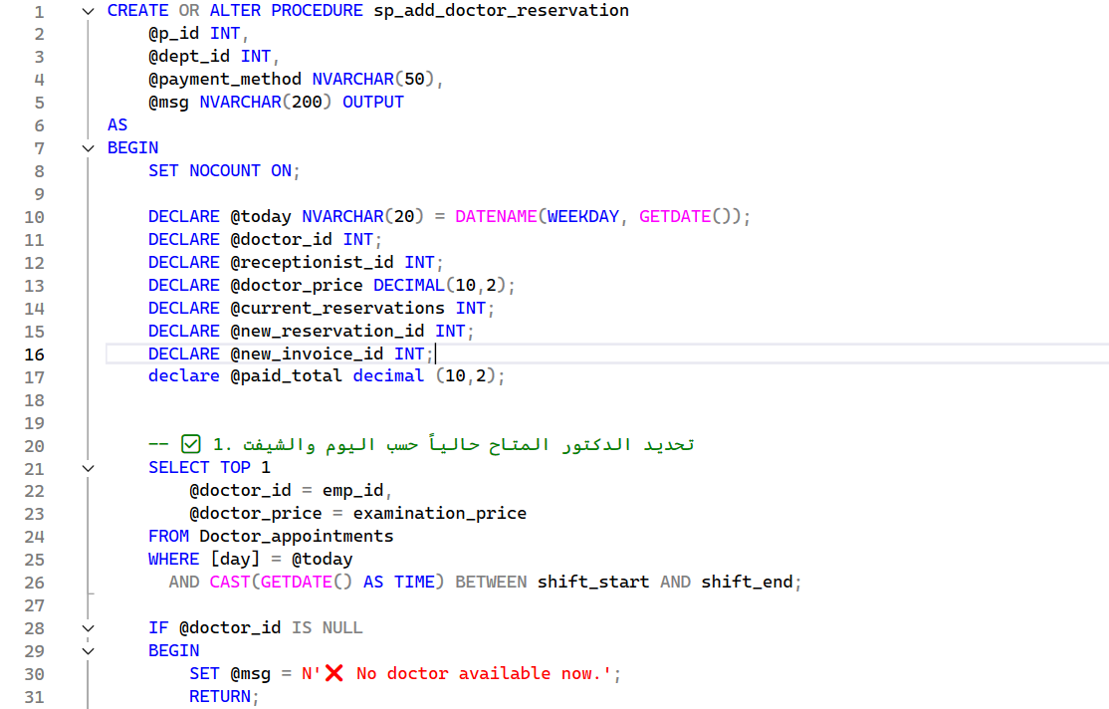

**SP_add_prescription_by_reservation**

This stored procedure creates a prescription record based on an existing appointment reservation.  
It resolves the patient from the reservation, validates the reservation, generates a new prescription ID, and inserts the prescription linked to the reservation.

**Execution flow**

* Input parameters:
  + @reservation_id: The appointment reservation ID for which the prescription will be created.
  + @notes: Optional free-text notes for the prescription.
  + @drug_name: Drug content stored as a single NVARCHAR(MAX) field (e.g. serialized or multiline text).
  + @msg: Output parameter used to return a status message.
* Looks up reservation data:
  + Queries appointment_reservation using @reservation_id.
  + Retrieves:
    - @p_id = p_id
    - @doctor_id = doctor_id
    - @app_date = date_time (not used later in the procedure).
  + If no row is found (@p_id remains NULL):
    - Sets @msg = 'Invalid reservation id.'
    - Returns.
* (Intended) checks for existing prescription:
  + There are two EXISTS checks against Prescription:
    - One to detect if a prescription with the same ID already exists.
    - Another to detect if the same reservation already has a prescription.
  + After these checks, if a matching record is found, the procedure returns with an appropriate message (e.g. “This reservation already have a prescription”).
  + **Note:** In the current implementation, @new_prescription_id is checked before it is assigned, so these conditions will never actually match. The intended behavior is to prevent duplicates for the same reservation.
* Generates a new prescription ID:
  + Computes:
  + SELECT @new_prescription_id = ISNULL(MAX(prescription_id), 0) + 1
  + FROM Prescription;
* Inserts the prescription:
  + Inserts a new row into Prescription with:
    - prescription_id = @new_prescription_id
    - date = CONVERT(date, GETDATE()) (today’s date, without time)
    - notes = @notes
    - p_id = @p_id (from the reservation)
    - reservation_id = @reservation_id
    - drug_name = @drug_name (raw text field).
* Final message:
  + Sets @msg = 'Prescription added successfully.'
  + Returns that message using SELECT @msg AS Message.

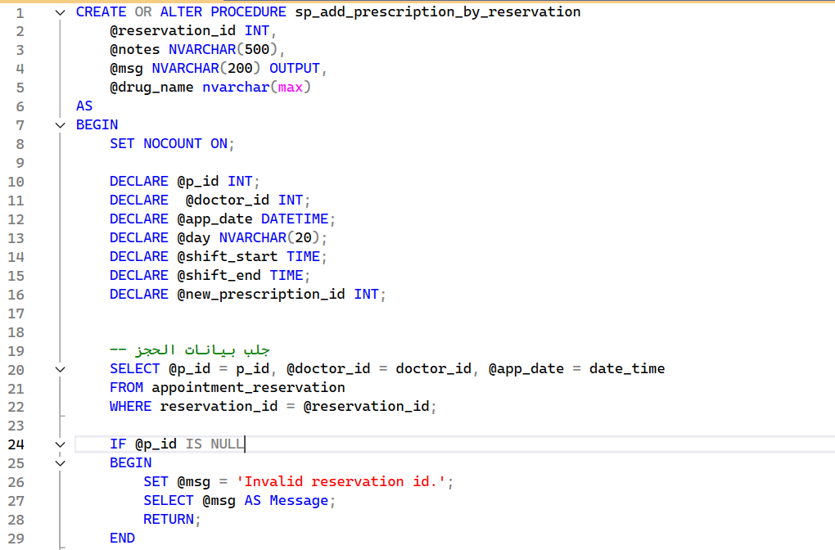









**SP_add_or_get_patient_by_ssn**

This stored procedure either returns an existing patient ID based on SSN or inserts a new patient and returns the newly generated ID.  
It centralizes patient lookup and creation logic so that callers can safely work with a valid p_id without duplicating patients.

**Execution flow**

* Input parameters:
  + @fname, @lname: Patient first and last name (used when inserting a new patient).
  + @email: Patient email.
  + @birth_date: Date of birth.
  + @gender: Patient gender.
  + @phone: Patient phone number.
  + @ssn: National ID / SSN used as a unique identifier.
  + @out_p_id: Output parameter that will contain the existing or newly created patient ID.
  + @msg: Output parameter used to return a status message.
* Attempts to find an existing patient by SSN:
  + Queries the Patient table for a row where ssn = @ssn.
  + If found, assigns the corresponding p_id to @out_p_id.
* If a matching patient is found:
  + The procedure:
    - Leaves the data unchanged (no insert).
    - Sets @msg = 'Patient already exists. Returned existing p_id.'.
    - Returns, with @out_p_id containing the existing patient ID.
* If no matching patient is found:
  + Generates a new patient ID:
    - @out_p_id = ISNULL(MAX(p_id), 0) + 1 from the Patient table.
  + Inserts a new record into Patient with:
    - p_id = @out_p_id
    - fname = @fname
    - lname = @lname
    - email = @email
    - birth_date = @birth_date
    - gender = @gender
    - phone = @phone
    - ssn = @ssn
  + Sets @msg = 'Patient inserted successfully.'.
* Final outcome:
  + In all cases, the caller receives:
    - A valid p_id via @out_p_id (either existing or newly created).
    - A message in @msg indicating whether the patient was found or inserted.

Top of Form

Bottom of Form

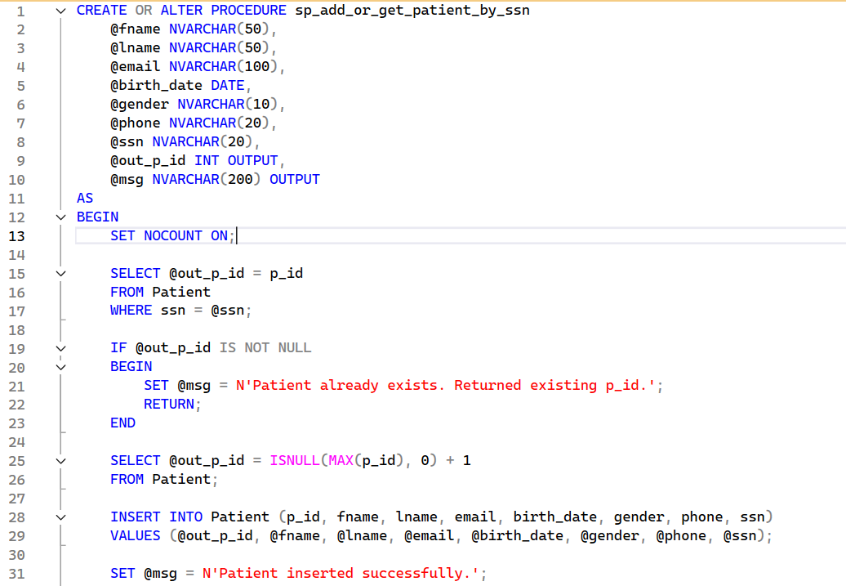



SSRS Reports

**Room revenue per year**

This SSRS report presents room revenue by reservation year within the hospital information system.

It compares total revenue for 2023 (155,150,000) versus 2024 (129,390,500) and breaks down revenue by room type.

In 2023, the highest revenue came from Surgery (64,900,000), followed by Recovery (32,450,000) and ICU/Emergency.

In 2024, Surgery remains the top contributor (41,950,000), followed by Emergency (21,618,000), then Recovery and ICU.

Overall, 2024 revenue is lower than 2023 by about 16.6%, helping management assess trends and support capacity and pricing decisions.

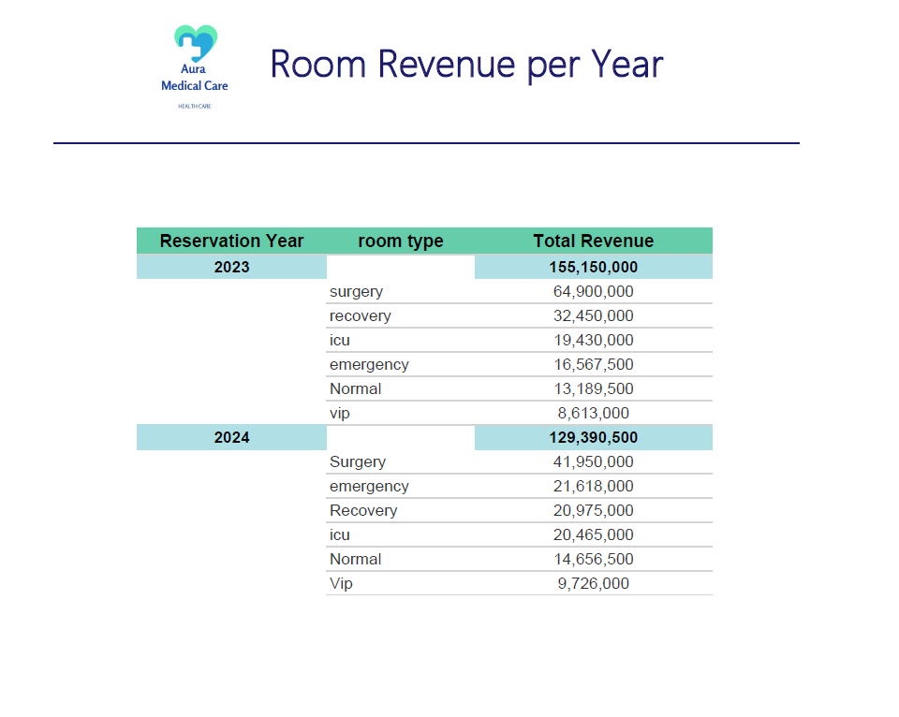

Bottom of Form

**Top 10 radiology by revenue**

This SSRS report shows the Top 10 Radiology tests by revenue, grouped by Test Year, including total times performed and total price for each exam.

In 2023, the top 10 exams were performed 266 times with a total revenue of 1,886,000, led by HIDA Scan (231,000) and CT Myelogram / X-ray Spine (217,000 each).

In 2024, the top 10 exams were performed 191 times with a total revenue of 1,362,500, led by Ultrasound Kidney (175,000) and Digital X-ray (168,000).

Overall, 2024 revenue decreased by 523,500 (~27.8%) compared to 2023, along with a drop in total exam volume (266 → 191).

The report helps radiology management identify high-revenue modalities, track year-over-year trends, and support decisions around resource allocation and service planning.

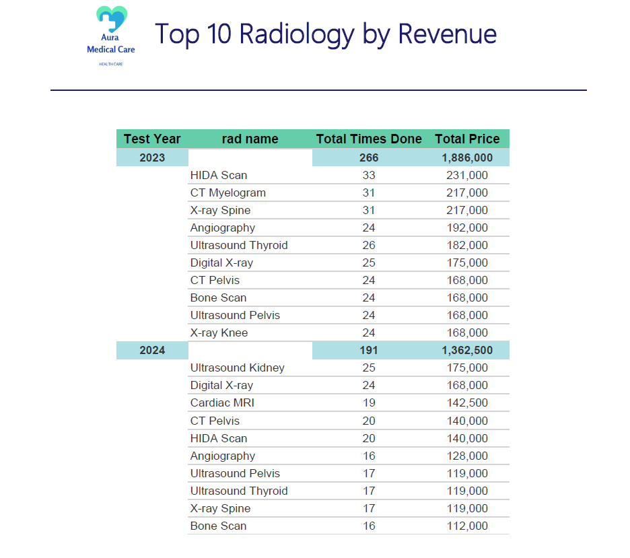

**Top 10 lab tests by revenue**

This SSRS report highlights the Top 10 Lab Tests by Revenue by Test Year, showing each test’s total times performed and total price.

In 2023, the top 10 tests were performed 760 times with total revenue of 736,850, led by Creatinine (128,000) and HbA1c (75,750).

In 2024, the top 10 tests were performed 674 times with total revenue of 687,000, with Creatinine (121,600) still the highest contributor.

Overall, 2024 revenue decreased by 49,850 (~6.8%) and volume dropped from 760 to 674 (~11.3%) compared to 2023.

The report supports lab management in identifying high-performing tests, monitoring year-over-year trends, and planning capacity, reagents, and staffing accordingly.

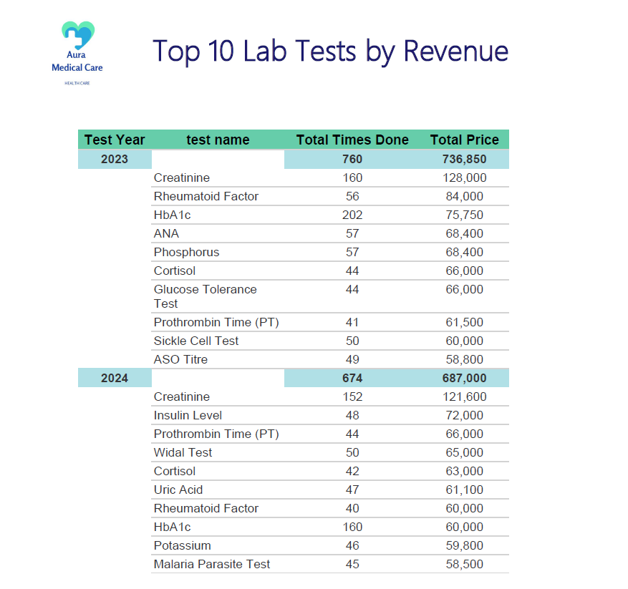

**Expenses report**

This SSRS Expenses Report summarizes the hospital’s expenses by year, with a monthly breakdown (and an Expense Type column for categorization).

For 2023, total recorded expenses are 40,036,200, with the highest month being August (5,035,100) and the lowest July (2,746,900).

For 2024, total recorded expenses are 38,819,146.36, with the highest month December (3,609,946.36) and the lowest April (2,973,100).

Overall, 2024 expenses decreased by 1,217,053.64 (~3.04%) compared to 2023.

The report helps finance track spending trends, identify peak expense months, and support budgeting and cost control decisions.

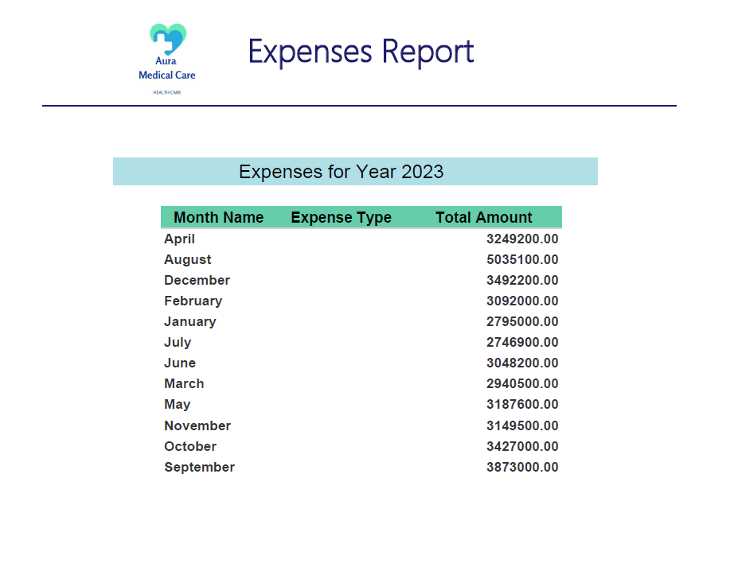

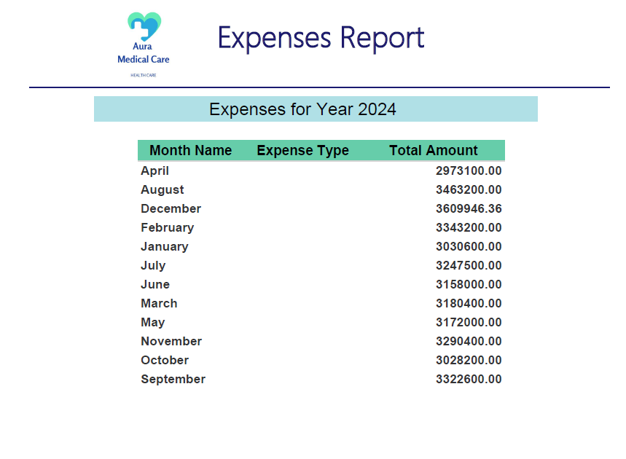

**Top 3 doctors per department**

This SSRS report shows the Top 3 doctors per department based on Total Appointments, including Emp ID and doctor name.

Each department includes a highlighted department subtotal (sum of the top 3), for example Cardiology: 6,920 and Dermatology: 12,410.

Orthopedics has the highest top-3 volume (15,600), led by Aya Hassan (7,866), followed by Reem Tarek (5,169) and Dina Ashraf (2,565).

Other high-volume departments include Pediatrics (11,110) and Ear Nose & Throat (11,140), indicating strong appointment demand.

The report helps management evaluate doctor workload and department performance, supporting scheduling, staffing, and capacity planning decisions.

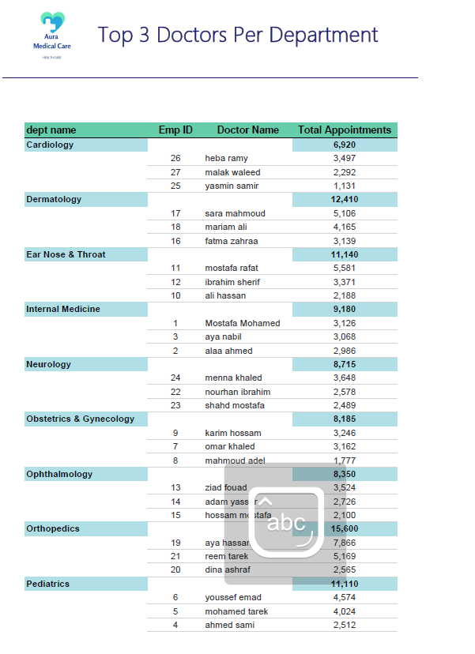

**Data modeling schema**

• This data model is designed in a star-schema style, where multiple fact tables capture hospital transactions and operational events, and shared dimension tables provide descriptive context.  
• The core fact tables include invoices, room reservations, appointment reservations, surgery reservations, lab reservations, radiology reservations, expenses, and salary, enabling both revenue and cost analytics.  
• Key dimensions such as Date, Patient, Employee, Department, Room, Surgery, Radiology, Lab Tests, Expense Type, Pharmacy Drugs, and Staff standardize reporting attributes and support consistent filtering and grouping.  
• Relationships are mainly one-to-many from dimensions to facts, which improves query performance and ensures accurate aggregations across different hospital services.  
• This structure supports building SSRS reports for year-over-year trends, departmental performance, service utilization, and financial KPIs using the same consistent data foundation.

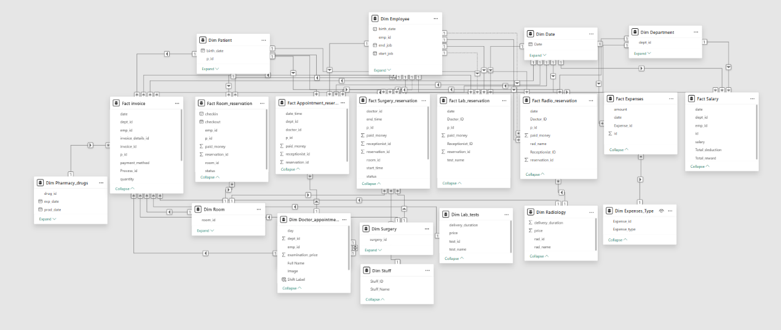

Dashboards

**HR System**

• The HR & Finance dashboards provide a clear overview of payroll and workforce KPIs, including headcount, salary trends, and compensation distribution.  
• The system tracks 99 active employees, with total salary of 41M, an average salary of 16.63K, and total base salary per month of 1.65M.  
• Salary analytics highlight how net salary is distributed by department and across months, helping identify which departments drive the largest payroll cost.  
• Incentives and penalties are monitored through 2,081 rewards and 1,394 deductions, total 2.52M rewards versus 602.67K deductions.  
• Rewards insights include an average reward per employee of 25.45K, with the 35–45 age group showing the highest reward concentration, and about 99% of employees receiving rewards.  
• Deductions insights show an average deduction per employee of 6.09K, with the 30–34 age group having the highest deductions, and about 89% of employees impacted by deductions.  
• The dashboards also segment salaries into High (26), Intermediate (35), and Low (38) salary groups to support budgeting, fairness checks, and HR policy decisions.

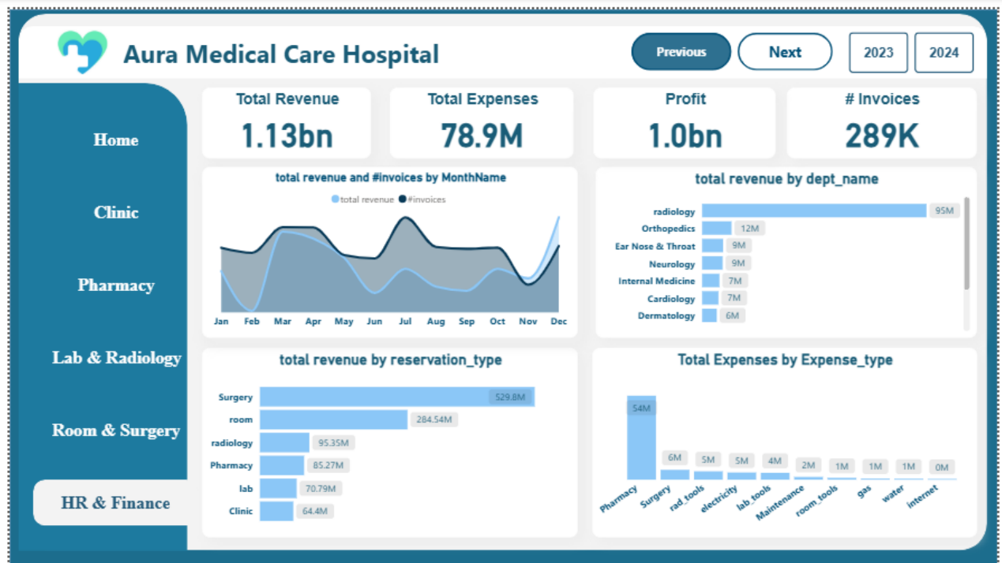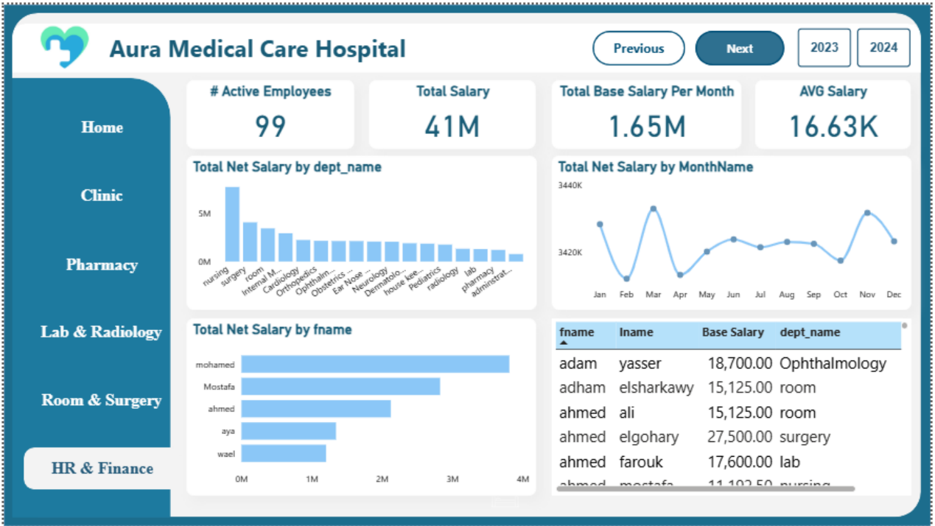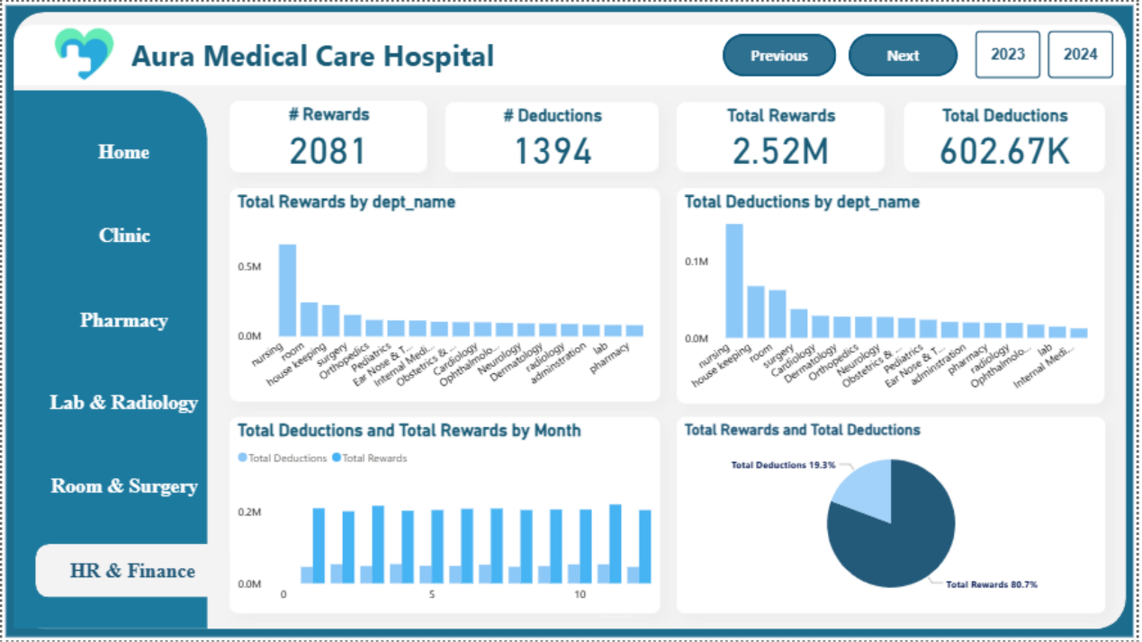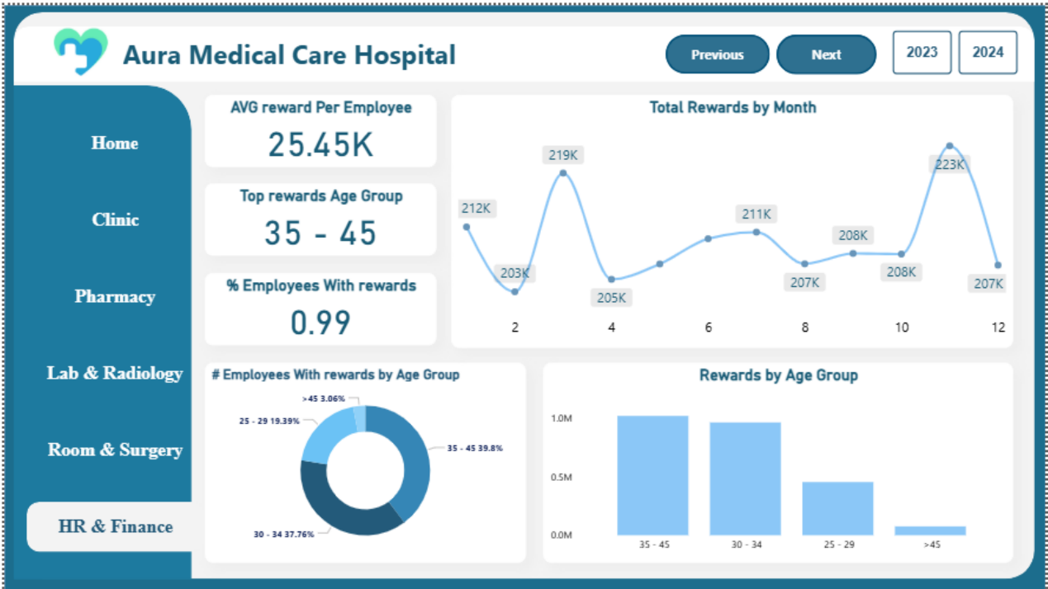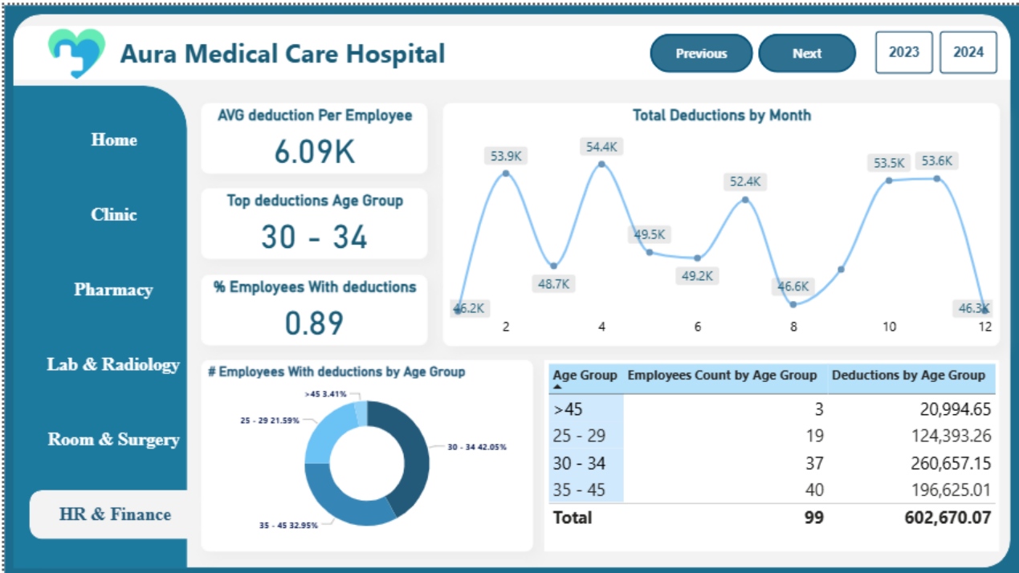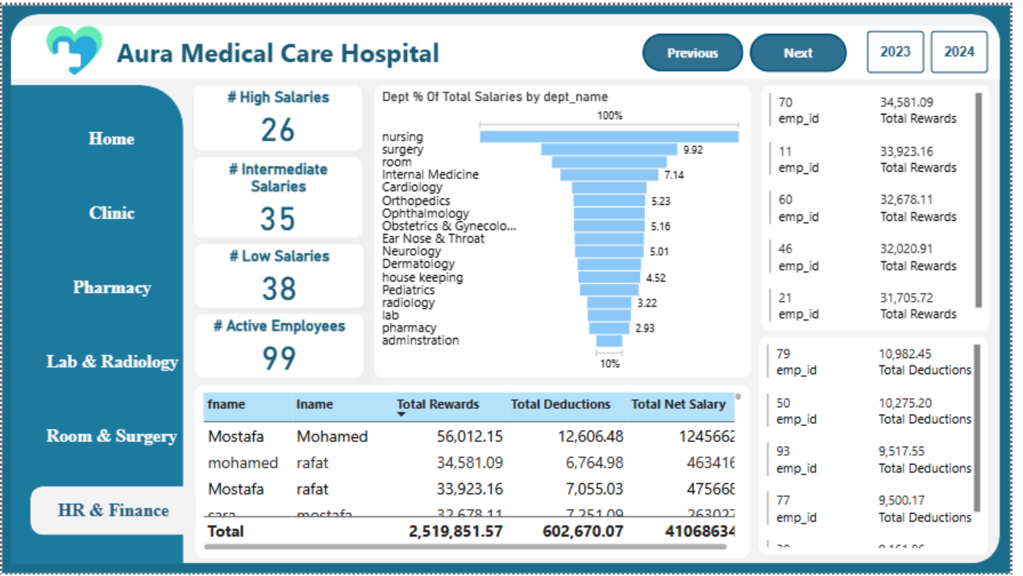

**Clinic System**

• The Clinic system dashboards provide a clear operational overview by separating insights into Doctors and Patients views to support clinic performance monitoring.  
• On the Doctors page, the clinic has 27 active doctors across 9 clinic departments, with total doctor appointments summarized at 3.39K.  
• The average examination price is 711, and the examination price distribution shows most services clustered around three main price points (600, 800, and 1000).  
• The “Best Doctors” visual highlights the top performers by appointment volume, led by Samir Mohamed (7.87K), followed by Mostafa Rafat (5.58K), Reem Tarek (5.17K), Sara Mahmoud (5.11K), and Youssef Emad (4.57K).  
• The appointments trend over time shows a gradual decline across the displayed days, moving from 677 down to 613, helping identify demand patterns.  
• On the Patients page, the dashboard tracks a total of 15K patients, with 9,368 females (63%) and 5,582 males (37%), an average age of 39, and 6.13 visits per patient.  
• Patient segmentation shows the highest volume in the 45–59 and 30–44 age groups (3.2K each), and the spending chart highlights top spenders (e.g., Mona Hafez, Nour Yehia, and Ibrahim Fouad) to support revenue and loyalty analysis.

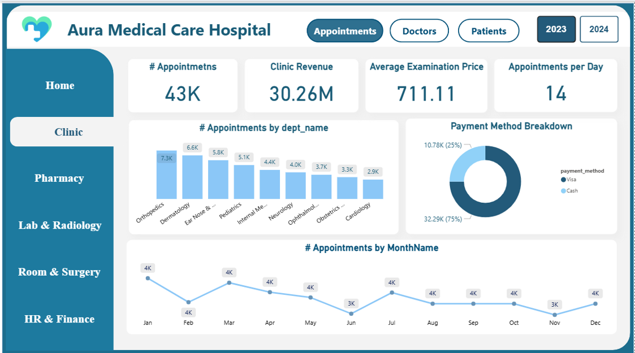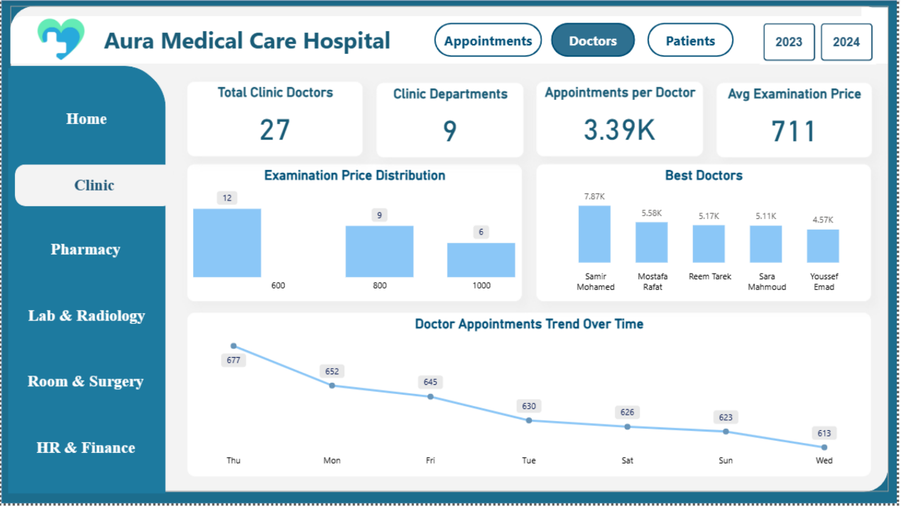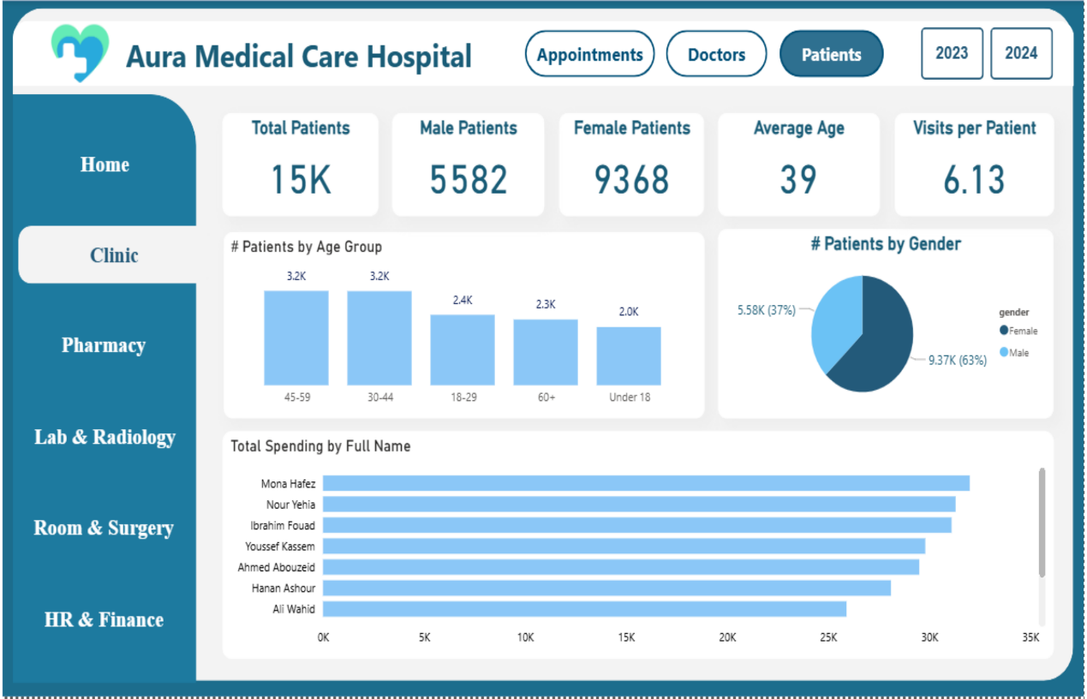

**Pharmacy System**

• The Pharmacy System dashboards provide a full view of medication inventory and spending, covering stock levels, expiry risk, and monthly pharmacy expenses.  
• Current inventory KPIs show a Total Stock Quantity of 278K and a Total Stock Value of 46.33M, supporting real-time stock monitoring and valuation.  
• Expiry control indicators highlight 62 expired drugs and 54 items expiring soon, with an estimated Total Expired Loss of 2.37M.  
• Drugs are categorized by expiry status where 89.83% are Valid, 5.43% are Expired, and about 4.74% are Expiring Soon, helping prioritize proactive actions.  
• The expiry-year distribution shows the largest expired quantity concentrated in 2026 (203K), with much smaller quantities in later years (e.g., 17K in 2027 and 8K in 2028).  
• The expired-drugs table lists high-impact items by quantity and value, such as Cefixime 608 (494 units) and Losartan 643 (489 units), supporting targeted stock write-off analysis.  
• Spending analytics track Total Pharmacy Expenses by month ranging from 3.90M (Jan) up to 5.16M (Dec), and compare Total Pharmacy Expenses (53.89M) against Total Expenses (78.9M) to understand pharmacy cost weight.

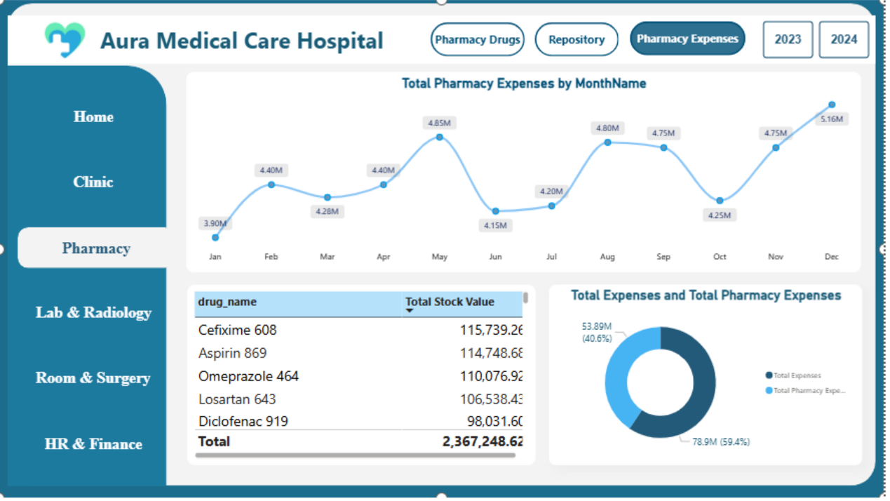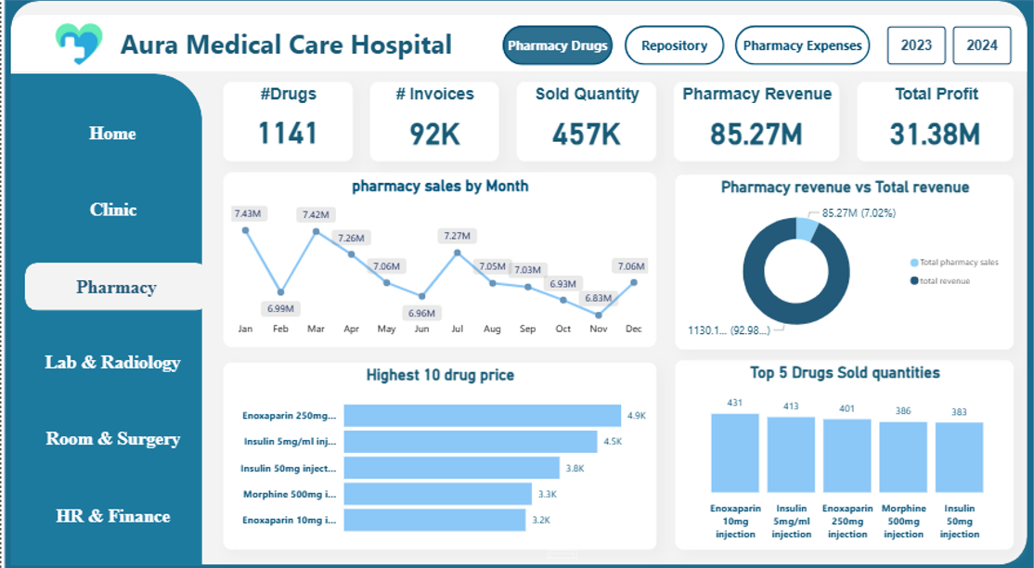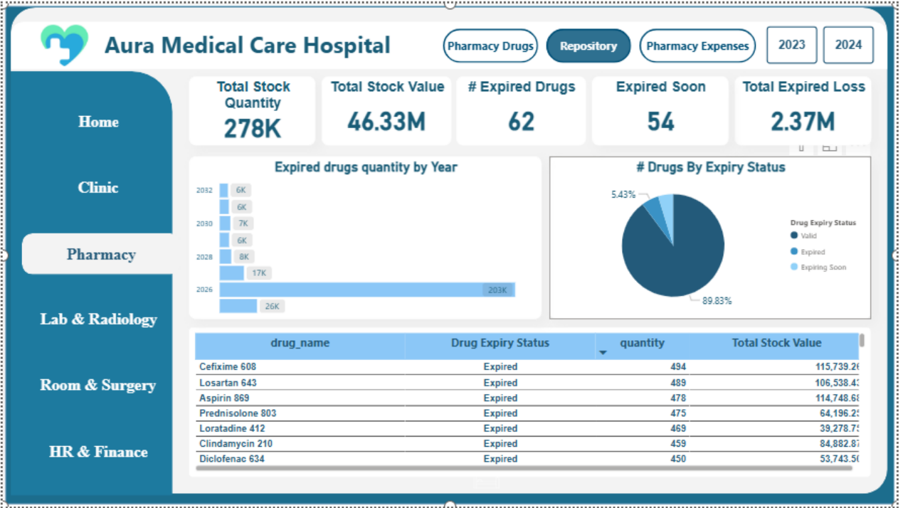

**Lab & Radiology System**

• The Lab & Radiology dashboards provide an end-to-end view of diagnostic operations, combining service volume, patient activity, turnaround time, and financial performance.  
• On the Laboratory page, the system records 39K lab reservations served by 14K unique patients, with an average payment per reservation of 732 and an average delivery duration of 12 hours.  
• Lab demand by test shows Creatinine as the top test (156 reservations), followed by Phosphorus (100), Rheumatoid Factor (96), Sickle Cell Test (95), and Potassium (90).  
• Lab contribution analysis shows Lab Revenue of 71M (6%) compared to Total Other Revenue of 1059M (94%), helping evaluate how much diagnostics contribute to overall revenue.  
• On the Radiology financial page, there are 125 radiology services with total Revenue of 95.35M, Cost of 5.35M, and Profit around 90M, supporting profitability tracking.  
• Radiology activity totals 37,809 reservations, with monthly demand peaking around April (4.2K) and dipping in October/November (2.2K), enabling seasonality and capacity planning.  
• On the Radiology service page, radiology reservations reach 38K with 10K unique patients, an average payment per reservation of 2.52K, an average delivery duration of 14 hours, and top revenue exams led by Angiography (2,376K) and Ultrasound (2,296K).

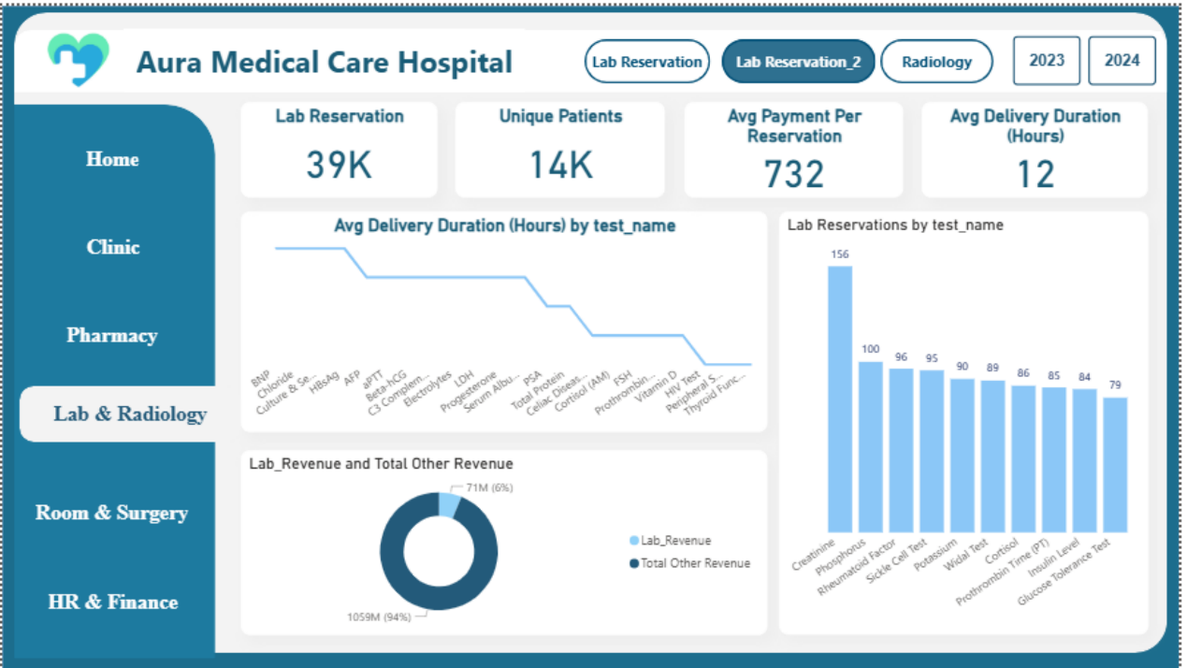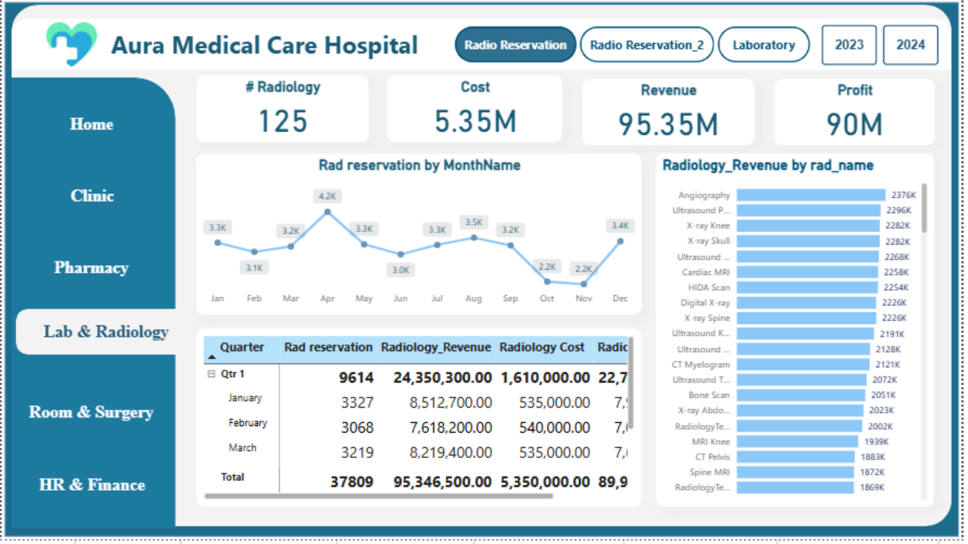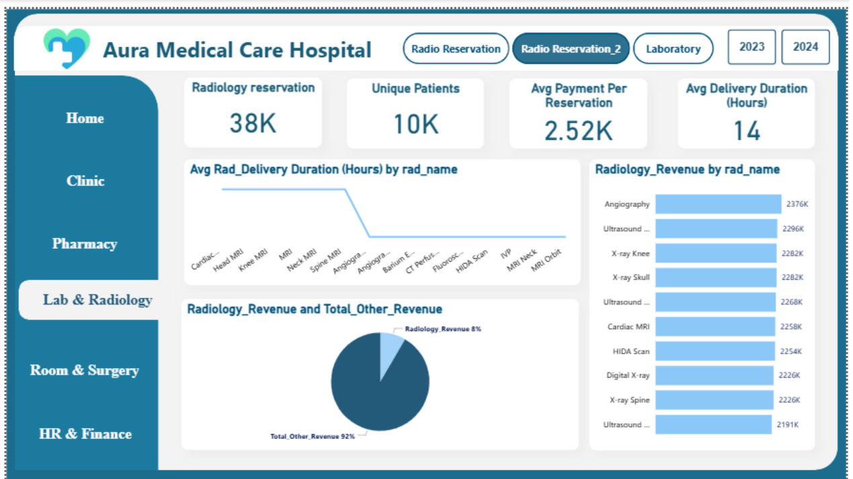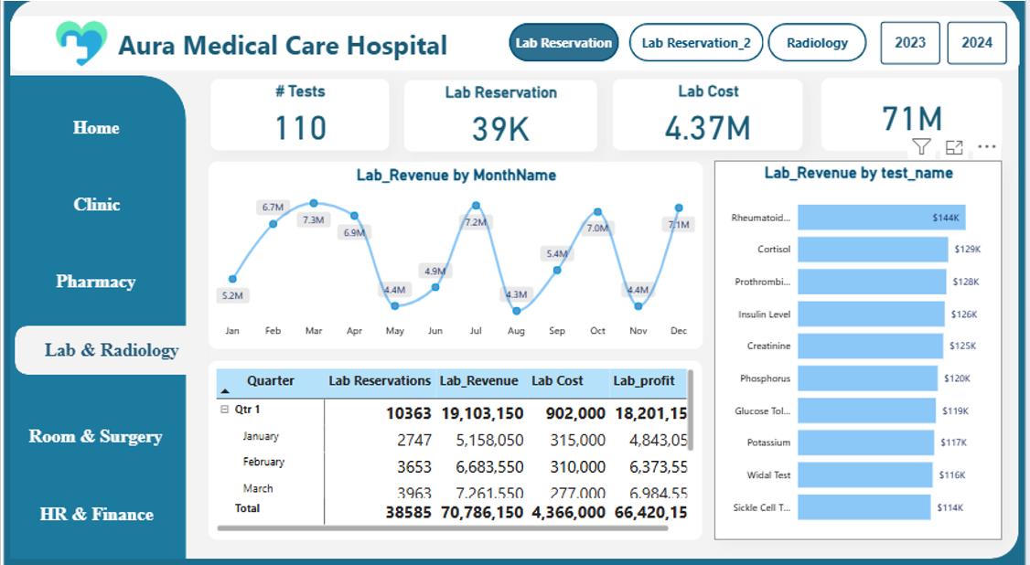

**Room & Surgery System**

• The Room & Surgery dashboards provide an integrated view of inpatient room utilization and surgical performance, combining volume, revenue, and operational KPIs.  
• For Rooms, total reservations reach 61K (61,072) with an occupancy rate of 100%, across 40 rooms, and a maximum stay of 7 days.  
• Room demand is led by Emergency (25,457 | 64.12%), followed by Recovery (10,685) and Surgery (10,685), while pricing ranges from 1,500/day (Emergency/Normal) up to 10,000/day (Surgery).  
• Monthly room reservations peak in August (5,937) and decline toward year-end, reaching 4,699 in November and 4,719 in December, helping identify seasonality in bed demand.  
• For Surgery financials, total surgery revenue is 529.80M with 6.30M cost and 523.50M profit, generated across about 11K invoices.  
• Surgical outcomes show a strong completion rate with 97.02% Done versus 2.98% Cancelled, and patient mix is 62.27% Female and 37.73% Male.  
• On Surgery operations, there are 11K surgery reservations, 7,710 patients, and 130 surgery types, with an average price of 48.42K; top surgeons by volume include Khalid Younes (2.3K) and Mostafa Saad (2.1K), while Internal Medicine leads department volume with 4,307 reservations and the highest average price (63,333.33).

